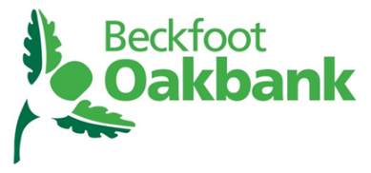
English Literature A-Level transition work
Summer 2021

Literature, in its many forms, is often a response to the world around us. Some writers seek to criticise social, historical, or cultural norms, while others may simply want to draw attention to them and allow the reader to shape their own interpretation.
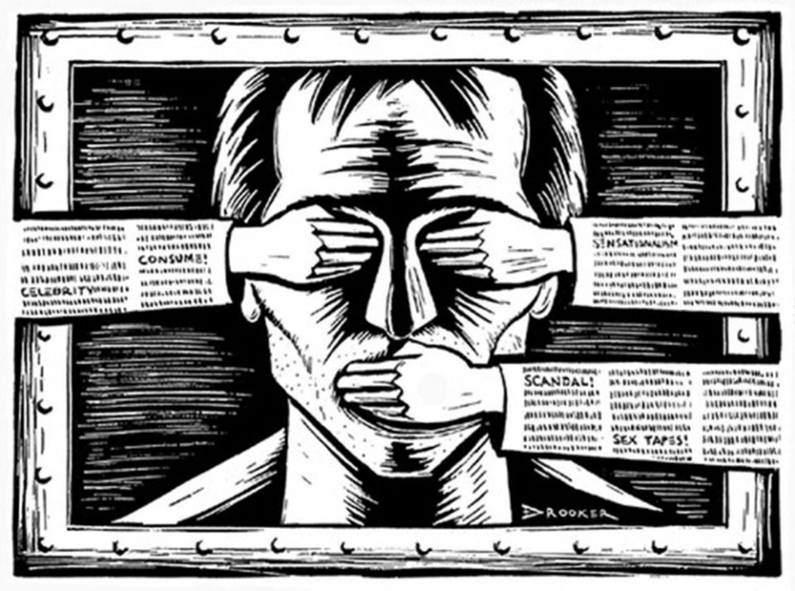

You will remember considering the influence of context (AO3) during your GCSE study and this is just as important at A-Level; we will consider the ways that writers show those on the margins of society and offer an insight to their unheard voices.

With this in mind…

Task 1 – Revise your knowledge of the contextual influences for each of the GCSE literature texts.
a) Note down the social/historical/cultural issues that each writer sought to shed light on in their writing.
b) Then write a brief summary of the writer’s intentions.
The first one has been done for you.

- An Inspector Calls – J.B. Priestley
a) Socialism, capitalism, gender and class inequality
b) J.B. Priestley uses the character of Inspector Goole as his political mouth piece to both shed light on social injustices caused by class and gender inequality, but also to give a voice to those who suffer at the hands of the wealthy elite.
2. Romeo and Juliet – William Shakespeare
a) _________________________________________________________________________________
b) _________________________________________________________________________________
_________________________________________________________________________________
_________________________________________________________________________________
3. (From the Power and Conflict poetry anthology) Checking Out Me History - John Agard
a) _________________________________________________________________________________
b) _________________________________________________________________________________
_________________________________________________________________________________
_________________________________________________________________________________

Advice on preparing for A Level
Research and recap your knowledge and understanding of these issues before September.
We are reading in the context of the prosecution of the police officers who were convicted of George Floyd’s murder. His murder happened at the hands of white policemen and this led to an uprising against injustice sparked by the terrible legacy of the slave trade.
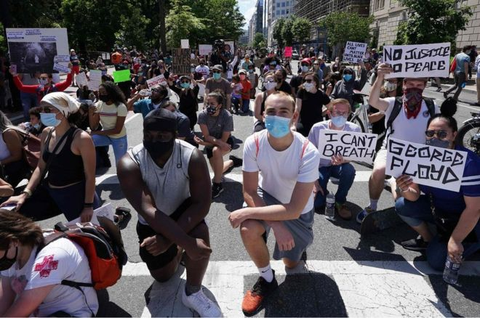

Tamika Mallory is an American activist who spoke out about the protests which took place in 2020. Watch the video here:
https://m.facebook.com/BET/videos/255902868961333/?refsrc=https%3A%2F%2Fm.facebook.com%2Fstory.php%3Fref%3Dm_notif&ref=m_notif&notif_t=comment_mention&_rdr

One of the texts you will study at A Level was written in 2009 but set in 1962. While an understanding of the context in which the text was written and set is important, it is equally as important to consider the ways in which the novel is still relevant today.
Task 2 Read the information about the novel The Help by Kathryn Stockett on the next page and complete the tasks that follow.
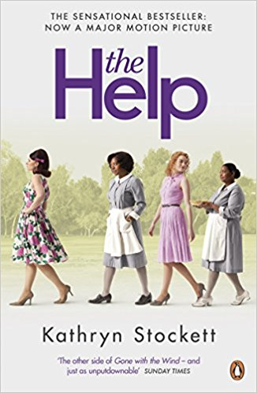

Told through the voices of three women, who in different ways defy the labels stuck on them by society, this novel challenges white privilege and sexism.

Enter a vanished and unjust world: Jackson, Mississippi, 1962. Where black maids raise white children, but aren't trusted not to steal the silver . . .
There's Aibileen, raising her seventeenth white child and nursing the hurt caused by her own son's tragic death; Minny, whose cooking is nearly as sassy as her tongue; and white Miss Skeeter, home from College, who wants to know why her beloved maid has disappeared.
Skeeter, Aibileen and Minny. No one would believe they'd be friends; fewer still would tolerate it. But as each woman finds the courage to cross boundaries, they come to depend and rely upon one another. Each is in a search of a truth. And together they have an extraordinary story to tell...

'The other side of Gone with the Wind - and just as unputdownable' The Sunday Times
'Harper Lee's classic novel To Kill a Mockingbird has changed lives. Its direct descendent The Help has the same potential . . . an astonishing feat of accomplishment' Daily Express

1. Thinking about the book cover, blurb and reviews of the novel on page 4, respond to the following:

- Explain what you think the writer’s intentions might have been in writing this novel.
________________________________________________________________________________________________________________________________________________________________________________________________________________________________________________________________________________________________________________________________________________________________________________________________________________
- How might current political and social affairs shape the way you read this novel? Do you think George Floyd’s murder and the subsequent riots will change the way you interpret the experiences of the women in the novel?
________________________________________________________________________________________________________________________________________________________________________________________________________________________________________________________________________________________________________________________________________________________________________________________________________________________________________________________________________________________________________________________________________________________________________________________________________________________________________________________________________________________________________________________________________________________________________________________________________________________________________________________________________________________________________________________________________________________________________________________________________________________________________________________________________________________________________________________________________________________________________________________________________________________________________________2. Read this extract from the opening of the novel and then respond to the questions.
a) Summarise your first impressions and explain your initial feelings about the text.
________________________________________________________________________________________________________________________________________________________________________________________________________________________________________________________________________________________________________________________________________________________________________________________________________________________________________________________________________________________________________________________________________________________________________________________________________________________________________________________________________________________________________________________________________________________________________________________________________________________________________________________________________________________________________________________________________________________________________________________________
________________________________________________________________________________
- How does the writer introduce the themes and characters? Highlight and annotate the passage, labelling the techniques the writer uses and making a note of the effect of her language choices. Then write one paragraph explaining how language is used in this opening extract to give us an impression of the characters.
________________________________________________________________________________________________________________________________________________________________________________________________________________________________________________________________________________________________________________________________________________________________________________________________________________________________________________________________________________________________________________________________________________________________________________________________________________________________________________________________________________________________________________________________________________________________________________________________________________________________________________________________________________________________________________

- Remind yourself of the context on page 4. How important do you think the social, historical and cultural background is to understanding and appreciating the writer’s work? Give reasons for your answers.
________________________________________________________________________________________________________________________________________________________________________________________________________________________________________________________________________________________________________________________________________________________________________________________________________________________________________________________________________________________________________________________________________________________________________________________________________________________________________________________________________________________________________________________________________________________________________________________________________________________________

Task 3
Research the time and place The Help was written in: Jackson, Mississippi, 1962.
Summarise your findings and then explain how you did your research and how reliable your sources are.
________________________________________________________________________________________________________________________________________________________________________________________________________________________________________________________________________________________________________________________________________________________________________________________________________________________________________________________________________________________________________________________________________________________________________________________________________________________________________________________________________________________________________________________________________________________________________________________________________________________________________________________________________________________________________________________________________________________________________________________________________________________________________________________________________________________________________________________________________________________________________________________________________________________________________________________________________________________________________________________________________________________________________________________________________________________________________________________________________________________________________________________________________________________________________________________________________________________________________________________________________________________________________________________________________________________________________________________________________________________________
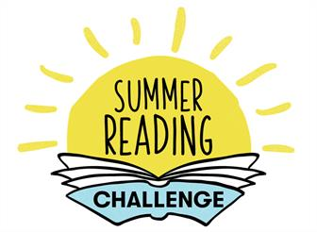

Reading widely is hugely important in your study of English Literature. The more you read, the more exposure to a range of diverse viewpoints, experiences, and significant historical moments you will have. Not only will this undoubtedly help to shape your interpretations of the texts you will study for your exams, it will also be excellent preparation of the none exam assessment unit of the course where you will independently select texts to examine and explore critically.
Here are some recommendations, particularly if you are interested in reading stories from/about under-represented/unheard voices.

- The Colour Purple – Alice Walker
- Unheard Voices – Malorie Blackman
- Everything I Never Told You – Celeste Ng
- Anita and Me – Meera Syal
- Pigeon English – Stephen Kelman
- Beloved – Toni Morrison
- Things Fall Apart – Chinua Achebe
- Zadie Smith – White Teeth
- To Kill a Mockingbird – Harper Lee
- A Woman Is No Man – Etaf Rum
- Persepolis – Marjane Satrapi
- The Hate U Give – Angie Thomas

