Beckfoot Oakbank
A Level Sociology
An Introduction
Summer Tasks

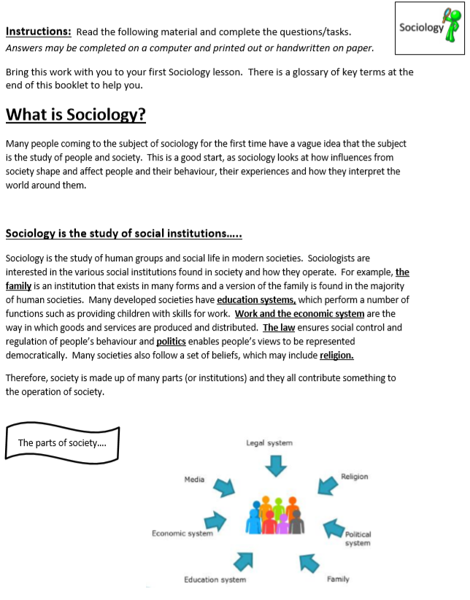

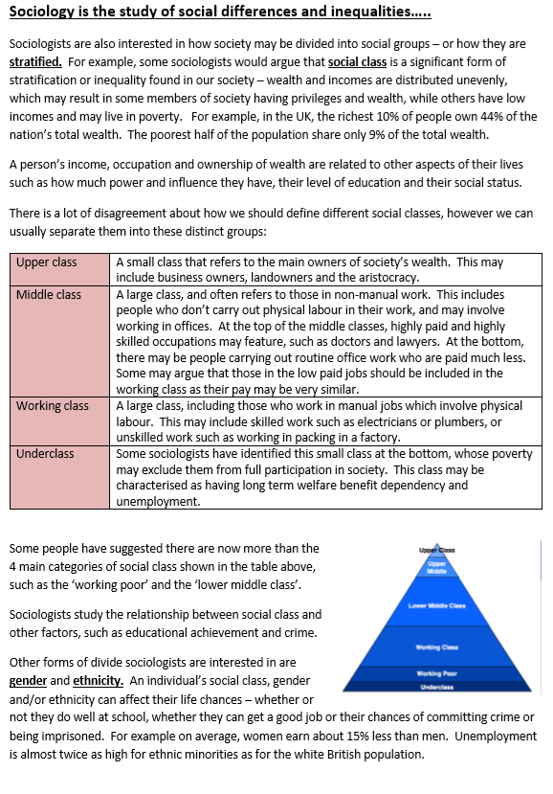

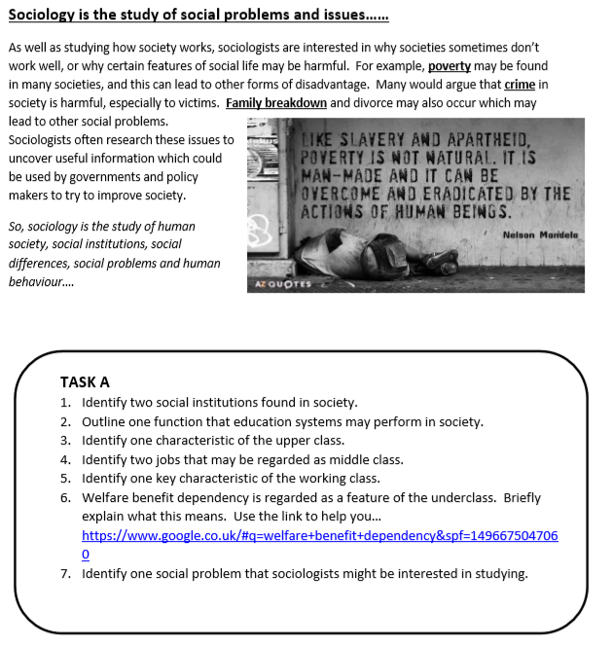

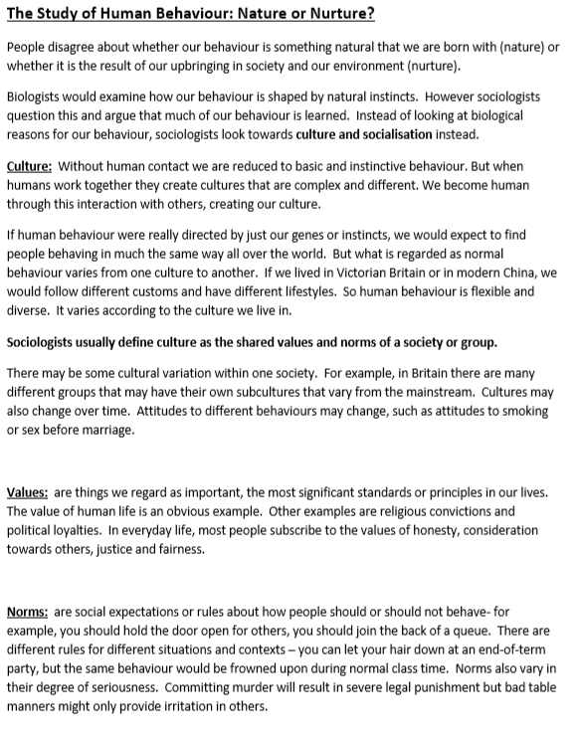

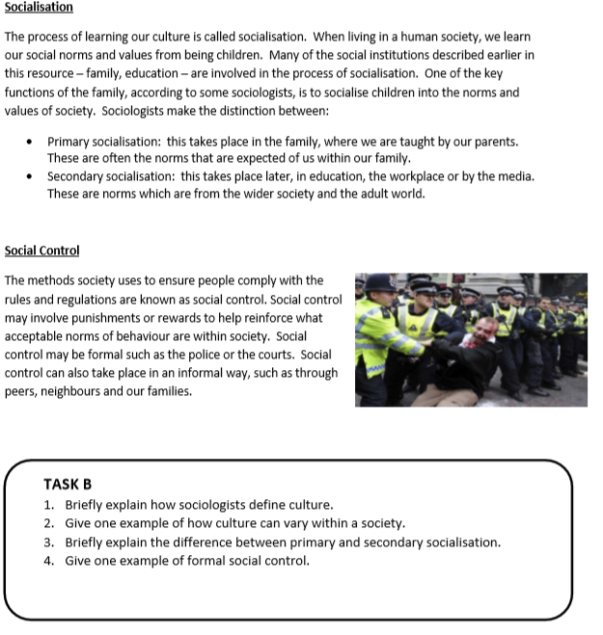

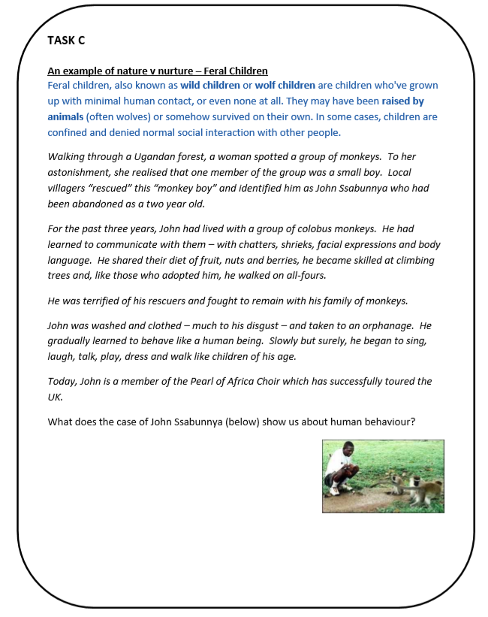

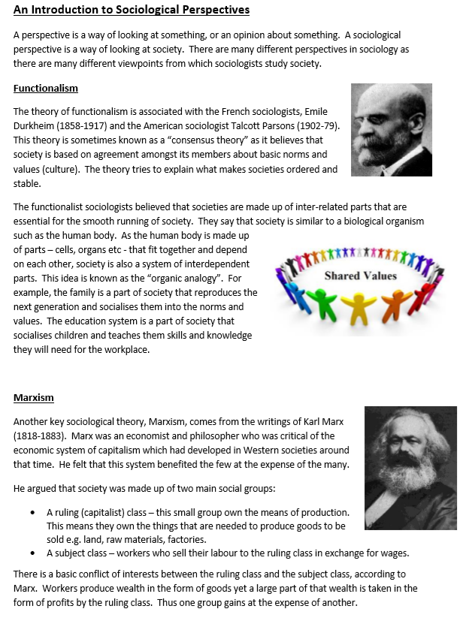

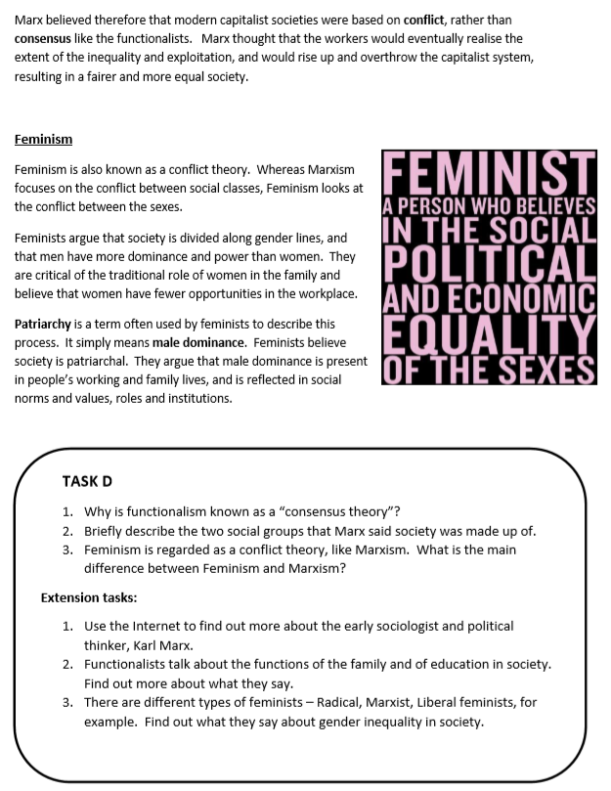

Debates in Society:

Socialisation is how we learn our culture, including language, beliefs and many behaviours.
Sociologists are interested in the role that people play in helping socialise children.
Most Sociologists think that upbringing (nurture) plays a key role in socialising children into different cultures
Feral children are children who spend time growing up without any human contact.

Your task is…
1) To research both sides of the debate. Mail on Sunday columnist Peter Hitchens outlines his position on his blog (in favour of grammar schools http://hitchensblog.mailonsunday.co.uk/grammar-schools/), and Wikipedia has a good overview of this debate.
2) What position does each of the other political parties take on this issue?
3) What do you think? Explain your reasoning.
Last year, the Conservatives announced they would be expanding the number of grammar schools in the UK.

There has been an extremely fierce debate over the fairness of grammar schools (selecting by ability) since their conception in 1944., with some arguing that grammar schools unfairly benefit the middle-classes, while others argue that it gives working-class children a chance that they otherwise wouldn’t have had.

Your task…
1) Research different perspectives on this debate.
2) Write your own response to the question, Is the Burqa oppressive or empowering.

The Burqa (a body length garment with a mesh covering the face) is an item of clothing worn by some Muslim women.
Feminists often believe that girls and women are not given a choice to dress in this way but are pressured by their parents, husbands and the local Muslim community to do so
However, there are signs that Western Muslim girls and women, especially those who are middleclass and educated, are increasingly choosing to wear the hijab in particular.

Your task is...
1) Research the London riots, produce a summary of the events, how long they lasted and how the disorder spread.
2) Research the reasons for these riots; watch Youtube videos and read accounts in news articles at the time. Give reasons for the riots from different perspectives, for example, what did the rioters say – is there any reason to disbelieve their account? What did people from local communities (where the rioting happened) say were the causes, what did the government say were the reasons? State problems/strengths of these reasons as you discuss them.
3) In your own personal opinion, what was the main reason why people were rioting? Give

