Level 3 Criminology
Transition Pack
2021
Criminology: the scientific study of crime and criminals

You are required to complete ALL of the activities in this transition pack for submission in the first week of the new academic year. It will develop your thinking skills and vastly expand your knowledge of what criminology is.

Dear Criminology Student
You have chosen a subject that combines elements of psychology, law and sociology and that complements studies in humanities. Each unit has an applied purpose which demands that learning is related to authentic case studies – this is the interesting bit! It will certainly ‘keep you on your toes’ and make you think in ways you couldn’t imagine. You will certainly have a very different outlook on society by the end of your course.

In this transition pack there are 5 tasks that we would like you to complete, these will be of benefit to you when you start the course. If you have any questions please feel free to email: ag@oakbank.org.uk or yd@oakbank.org.uk.
All work should be completed in your booklet where possible or on lined paper/Word document and should be brought with you to your first lesson of Criminology in the new school year. Do not rush it. We advise that you complete different parts of the transition pack at different points in the Summer holiday, rather than leaving it all until the final week of your break.

Task 1 - Course Overview
This is a two-year course. Units 1 and 2 completed in the first year comprise an 8-hour Controlled Assessment plus a formal examination. This is replicated in Year 2 with Units 3 and 4. You must complete and pass ALL units to gain the Diploma. The overall grades will be recorded on a scale A*-E.

Unit 1: Changing Awareness of Crime (Controlled Assessment)
Unit 2: Criminological Theories (Exam)
Unit 3: Crime Scene to Courtroom (Controlled Assessment)
Unit 4: Crime and Punishment (Exam)

Look at the specification for more detail about these topics. You can find this at: https://www.wjec.co.uk/media/21xjkr24/wjec-applied-diploma-in-criminology-spec-e-03-06-2020.pdf

You will be expected to know and understand the information covered, to be able to apply that knowledge and understanding and to be able to analyse and evaluate that knowledge and understanding.

Read the specification carefully and make a note below of the sections there are to each Unit:

Unit 1: Changing Awareness of Crime
________________________________________________________________________________________________________________________________________________________________________________________________________________________________________________
Unit 2: Criminological Theories ________________________________________________________________________________________________________________________________________________________________________________________________________________________________________________
Unit 3: Crime Scene to Courtroom
________________________________________________________________________________________________________________________________________________________________________________________________________________________________________________
Unit 4: Crime and Punishment in Society
________________________________________________________________________________________________________________________________________________________________________________________________________________________________________________
Expectations of the course:
- Lessons consist of taking notes, group discussions, watching relevant DVDs/documentaries, group work and PowerPoint presentations.
- Homework consists of note making, wider reading, research, past exam questions, power points and essays. It is expected that about 5 hours a week will be spent on Criminology homework.
- The Reading and Watching List on the following page will help you to gain wider knowledge and a broader framework in which to apply your knowledge.
- Your progress will be reviewed on a regular basis. The review process will provide feedback at specific times throughout the year. You will also be expected to be within two grades of your target grade on each piece of work.
- You are expected to use the resources available to you in the library and common room here and are strongly encouraged to use libraries outside of school, not just the internet.
- Make a Criminology chat/whatsapp for discussion.
- Your folders of notes will be checked on a regular basis to see if you are organised and up to date with your work.
- USE YOUR STUDY TIME AND BE PRO-ACTIVE.

Reading List - Criminology
- 1984 – George Orwell
- Folk Devils and Moral Panics – Stanley Cohen
- A Glasgow Gang Observed – Patrick James
- Gang Leader For A Day – Sudhir Venkatesh
- Fake Law – The Secret Barrister
- Traces: Memoir of a Forensic Scientist and Criminal Investigator – Patricia Wiltshire
- My Life With Murderers – David Wilson
- A wide range of newspapers including The Guardian and Independent

Watching List - Criminology
- Any documentaries, including Panorama, Louis Theroux, Stacey Dooley, Mind of a Murderer etc
- Black Mirror series (Netflix)
- Goodfellas
- The Godfather (part 2 is the best)
- Legend
- McMafia (previously BBC i-player)
- Freedom Writer’s Diary
- Dangerous Minds
- Chernobyl (drama)
- When They See Us (Netflix)
- The Society (Netflix)
- Blood Diamond
- Ted Talks/Crime/Criminal Justice
- Orange is the New Black (Netflix)
- The Innocence Files (Netflix)
- Cold Case Files (Netflix)
- I Am A Killer (Netflix)
- When They See Us Now – Oprah Winfrey (Netflix)
- The Stanford Prison Experiment (Youtube)
- The Push – Derren Brown (Netflix)
- MacIntyre Undercover: The Chelsea Headhunters (Youtube)
- The Shawshank Redemption
- The Green Mile

Task 2 - Note Taking
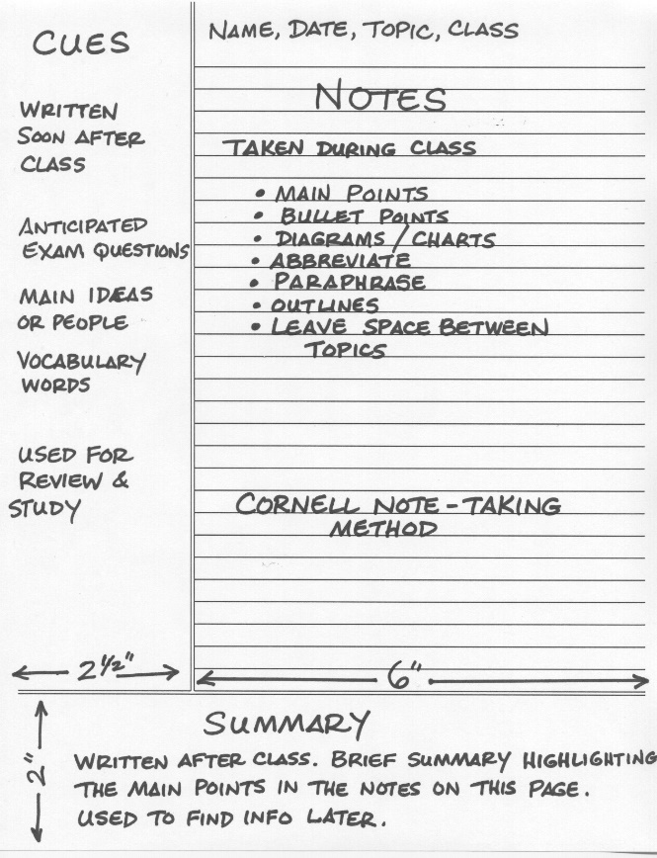
Throughout the course you will be required to take notes, one way of doing this is through I would the Cornell Notes system. Here is an extract about what Cornell Notes are: “There are many different ways of taking notes in school or at the university. Some prefer to take a structured approach and use an outline method to take notes, some may prefer a visual way and draw mind maps, some may even use no structure at all. However, there is one note-taking technique that is superior to others in many cases and science has proven that it is not only more efficient but also makes it a lot easier to review notes, for example when preparing for an exam. The technique we‘re referring to is called “Cornell Note Taking”. It is a system for taking, organizing and reviewing notes and has been devised by Prof. Walter Pauk of Cornell University in the 1950s”.

Why do I need to use this notetaking method?
This will encourage you to focus on taking your own notes. The reason why this is important is as an application subject we will need you to be able to write and explain the theories in your own words. This notetaking method will encourage you to summarise and condense notes down in a way which will support your learning. You will not need to buy anything special just your normal notebook/notepad and divide it into 3 sections. Below the image explains what the page will look like and what you use it for.
https://www.youtube.com/watch?v=ErSjc1PEGKE&app=desktop – this video will also explain how to take notes in this way.

Activity- Using the system above take notes on the video: https://www.youtube.com/watch?v=tdaqqlFQdTE

As well as this define the following key words:
- Crime
- Deviance
- Norms
- Values
- Criminal Justice System

Task 3 - Criminal fact file
Below are a list of victims and offenders for you to research:
Write a fact file for each (**Make sure you keep these for Year 12 they will be very useful!**) which should include the following information:
- Their crimes or crime that has been committed against them and victims
- Details of the crime committed – what type of crime was committed tax fraud or murder etc.
- Details of their sentence if there was any
- Information about their background which might explain their criminal behaviour such as head injuries, mental illness, childhood abuse
Task 4 – Types of Crime
Research the following types of crime. You need to understand the definition of the type of crime, the typical offender and the typical victim.

- State Crime

Definition________________________________________________________________________________________________________________________________________________________________________________________________________________________________________
Typical Offender __________________________________________________________________
________________________________________________________________________________
Typical Victim ____________________________________________________________________
________________________________________________________________________________
Example_________________________________________________________________________________________________________________________________________________________________________________________________________________________________________________________________________________________________________________________________________________________________________________________________________

- White Collar Crime

Definition________________________________________________________________________________________________________________________________________________________________________________________________________________________________________
Typical Offender __________________________________________________________________
________________________________________________________________________________
Typical Victim ____________________________________________________________________
________________________________________________________________________________
Example_________________________________________________________________________________________________________________________________________________________________________________________________________________________________________________________________________________________________________________________________________________________________________________________________________
- Moral Crimes

Definition________________________________________________________________________________________________________________________________________________________________________________________________________________________________________
Typical Offender __________________________________________________________________
________________________________________________________________________________
Typical Victim ____________________________________________________________________
________________________________________________________________________________
Example_________________________________________________________________________________________________________________________________________________________________________________________________________________________________________________________________________________________________________________________________________________________________________________________________________

- Technological Crimes

Definition________________________________________________________________________________________________________________________________________________________________________________________________________________________________________
Typical Offender __________________________________________________________________
________________________________________________________________________________
Typical Victim ____________________________________________________________________
________________________________________________________________________________
Example_________________________________________________________________________________________________________________________________________________________________________________________________________________________________________________________________________________________________________________________________________________________________________________________________________

- Hate Crime

Definition________________________________________________________________________________________________________________________________________________________________________________________________________________________________________
Typical Offender __________________________________________________________________
________________________________________________________________________________
Typical Victim ____________________________________________________________________
________________________________________________________________________________
Example_________________________________________________________________________________________________________________________________________________________________________________________________________________________________________________________________________________________________________________________________________________________________________________________________________

Task Five – All about hate crime

Since the public vote on BREXIT there has been a marked increase in hate crimes. Using the sources below and any others you feel are appropriate answer the questions below:
- http://www.independent.co.uk/news/uk/crime/brexit-hate-crime-racismstats-spike-police-england-wales-eu-referendum-a7126706.html
- https://www.victimsupport.org.uk/crime-info/types-crime/hate-crime
- http://www.stophateuk.org/
- http://www.lgbthatecrime.org.uk/

- What is hate crime?
- Who are the potential victims?
- Find two examples of real victims of hate crime and write a summary of each case
- Find 2 examples of support groups who help victims of hate crime and outline their aims and objectives
- Watch the following documentary on you tube (BBC3 the ugly face of disability – hate crime) https://www.youtube.com/watch?v=B03jduD9N5o&safe=active

Choose at least one of the things to do below:
1. Real stories Documentary on Honour Crime - https://www.bing.com/videos/search?q=dcoumentry+on+honour+killing&&view=detail&mid=ADA6F24272DD26F88D9AADA6F24272DD26F88D9A&&FORM=VRDGAR&ru=%2Fvideos%2Fsearch%3Fq%3Ddcoumentry%2Bon%2Bhonour%2Bkilling%26FORM%3DHDRSC4
2. BBC Documentary Love & Hate Crime - make sure you take notes on the campaign and why the campaign happened - https://www.bbc.co.uk/iplayer/episode/p07r371m/love-and-hate-crime-series-2-2-trouble-inparadise
3. BBC Documentary Jack The Ripper Case Reopened - make sure you take notes on the case - https://www.bbc.co.uk/iplayer/episode/m0003wdk/jack-the-ripper-the-case-reopened

Task Six - Crime and Deviance

Famous Faces and their crimes? Or deviance? Match the famous face to the act of crime or deviance.

- Trespassing and damage of property leading to loss of owner’s income
- Arrested for possession and being under the influence of drugs, possession of an unloaded gun and trespassing
- Arrested for protesting outside the South African embassy against unfair treatment of Black people in South Africa
- Arrested for assault, driving under the influence of drugs, driving whilst license was suspended
- Avoiding paying £20 million in tax that would help to pay for the NHS, Welfare and Schools in this country
- Driving under the influence of alcohol and causing a collision injuring two other people

Answers at the end!
Task Seven - Eye Witness Testimony
Take the Eye Witness Testimony test. Watch the video. When it tells you to pause, write down what you remember about the criminal.
https://www.youtube.com/watch?v=c6eknHXGM0c
Description:
Gender: ……………………………………………………………………………………………………………………………………………
Hair colour and length: ……………………………………………………………………………………………………………………
Clothing: …………………………………………………………………………………….......................................................
Anything else significant: …………………………………………………………………………………………………………………
…………………………………………………………………………………………………………………………………………………………
Were you right? Yes/ No / Some features were correct.

Now look at how the unreliability of eye witness testimony can affect real cases.
https://www.youtube.com/watch?v=u-SBTRLoPuo

Write a summary of issues with eye witness testimony below:
________________________________________________________________________________________________________________________________________________________________________________________________________________________________________________________________________________________________________________________________________________________________________________________________________________________________________________________________________________________________

Task Eight - Key Words
Find out what the following key words mean.
Key Term | Definition
Criminology
Crime
Social Definition
Legal Definition
Deviance
Genocide
Nature/Nurture
Decriminalisation
Moral Panic
Norms
Civil Liberties
Statute
Miscarriage of justice
Answers to Task 6

- Trespassing and damage of property leading to loss of owner’s income
- Arrested for possession and being under the influence of drugs, possession of an unloaded gun and trespassing
- Arrested for protesting outside the South African embassy against unfair treatment of Black people in South Africa
- Arrested for assault, driving under the influence of drugs, driving whilst license was suspended
- Avoiding paying £20 million in tax that would help to pay for the NHS, Welfare and Schools in this country
- Driving under the influence of alcohol and causing a collision injuring two other people

- Ant McPartlin – F
- Lindsay Lohan – D
- Robert Downey Jr – B
- Gary Barlow – E
- Jeremy Corbyn – C
- Theresa May - A

