**Transition Pack for BTEC Level 3 Principles and Application of Science**

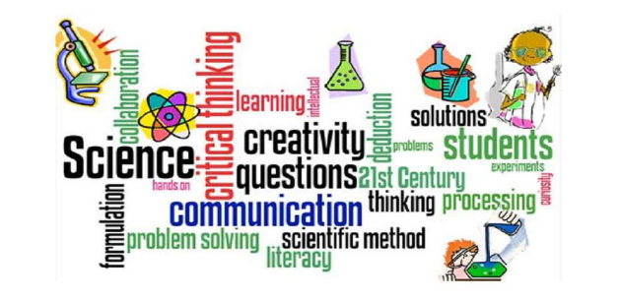

**Get ready for Sixth Form!** 

In year 11 you learn about the structure and function of the different organelles that make up plant, animal and bacterial cells. You will need to recall all of this information, as well as know the cells in much more detail, labelling and describing organelles that you didn’t learn about in year 11 such as the golgi apparatus. Use the internet to see if you can label the cells below and describe the functions of the different organelles.

Structure and function of cells and tissues

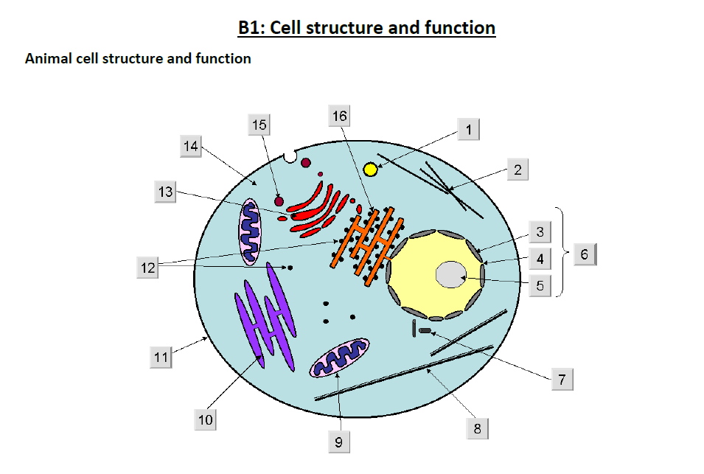

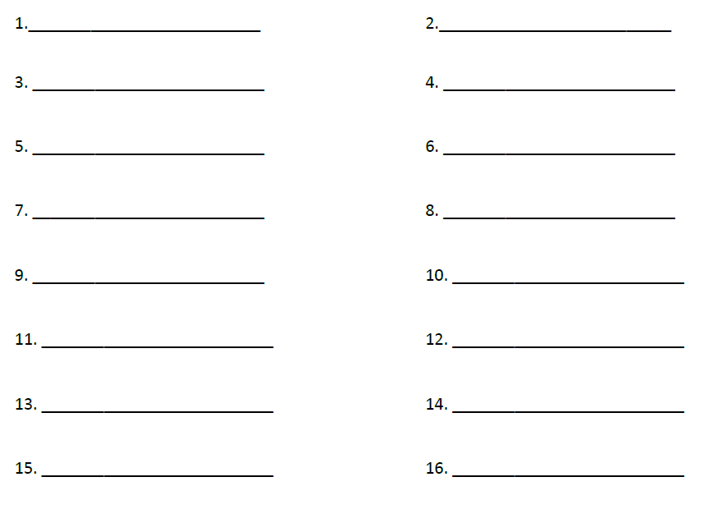

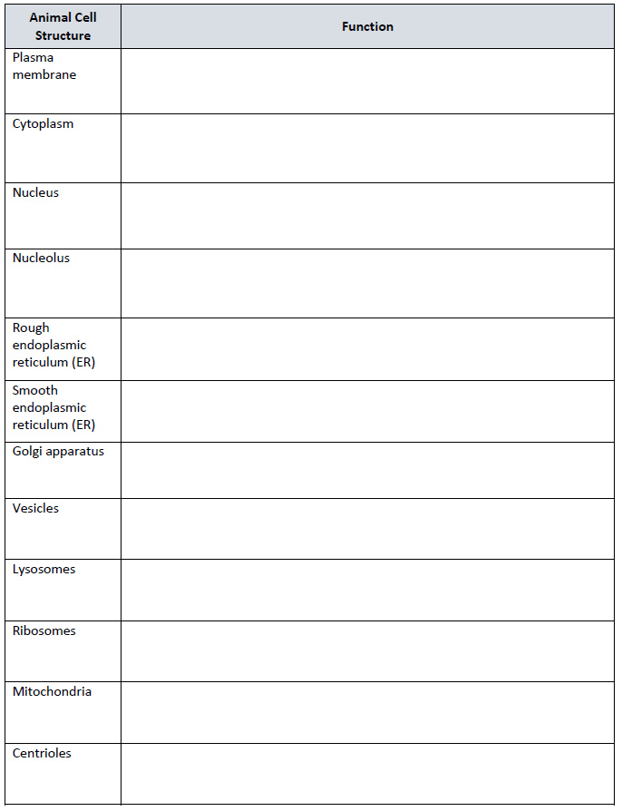

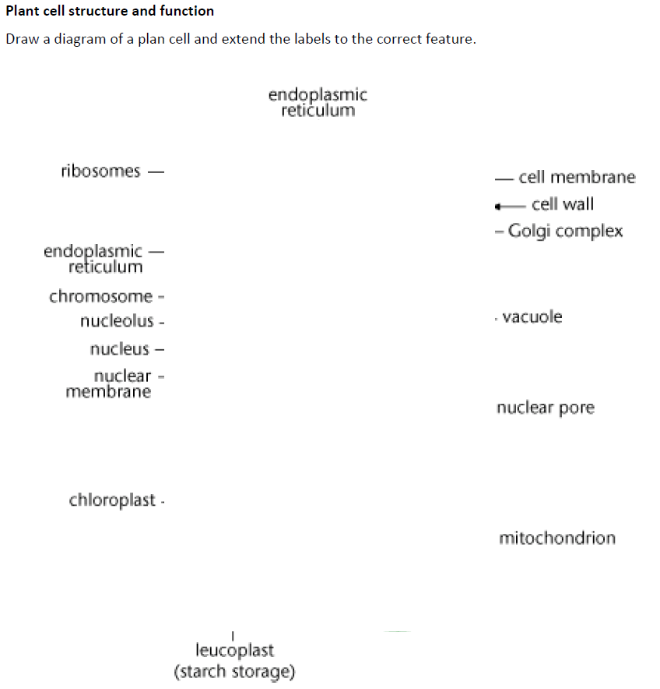

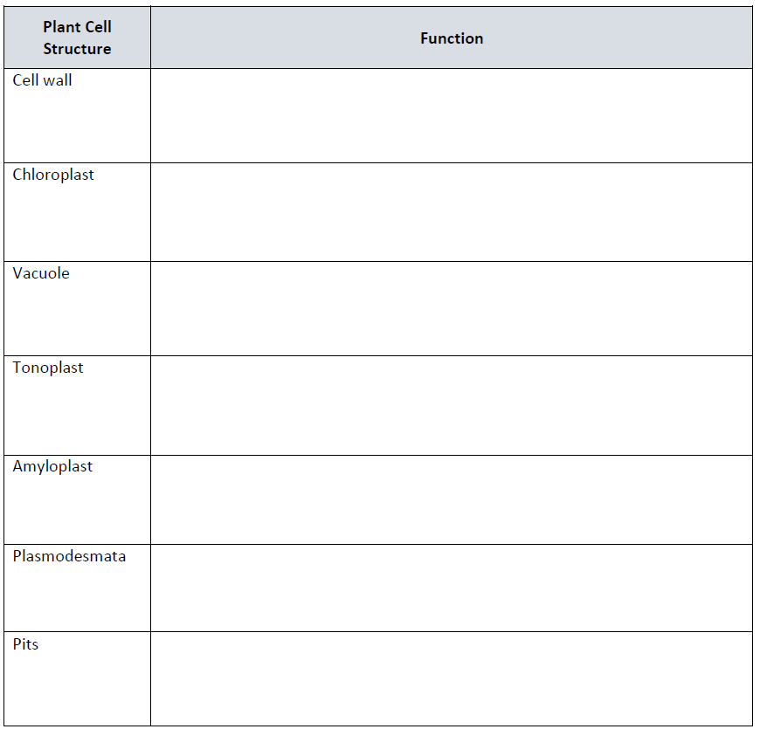

In Year 11 you learn about how some cells are specialised. In year 12 we will review your existing knowledge and build on this. Knowing the specialisation of the cells listed below makes up part of the BTEC applied level 3 specification.

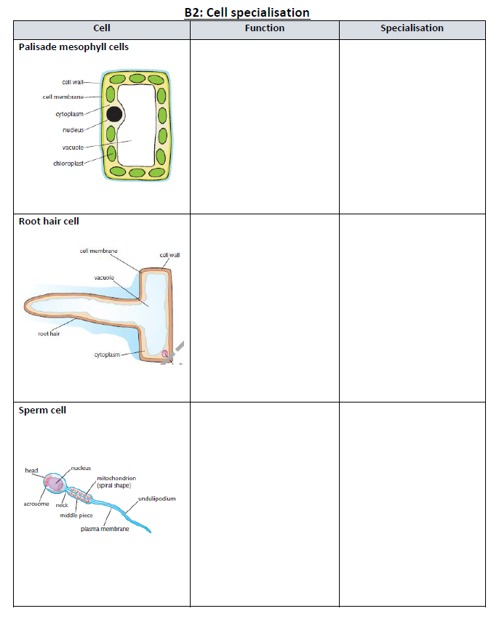

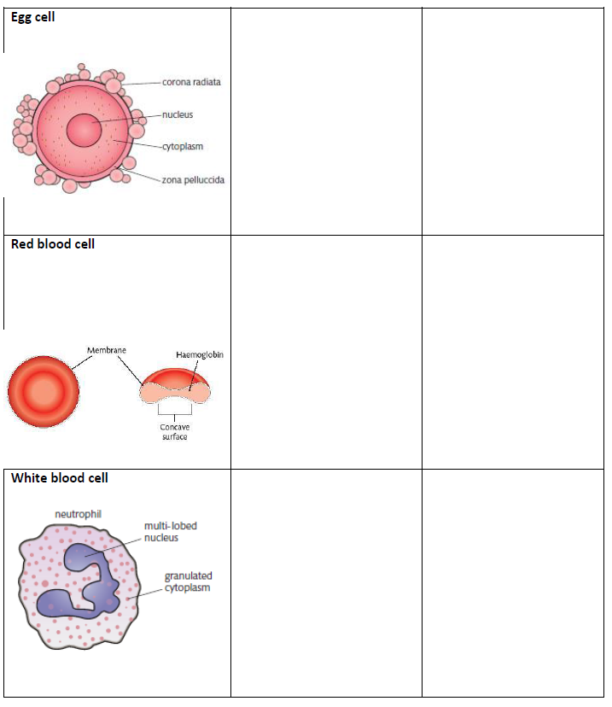

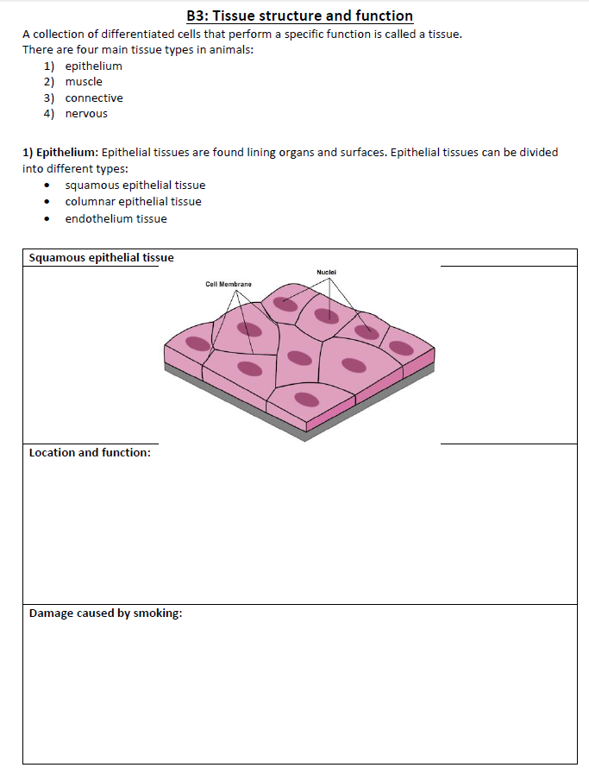

In year 11 you learn that a tissue is a group of cells with a similar structure and function, in year 12 we will learn how there are 4 main types of tissues and learn about some of them in detail especially the epithelium and different types of epithelium.

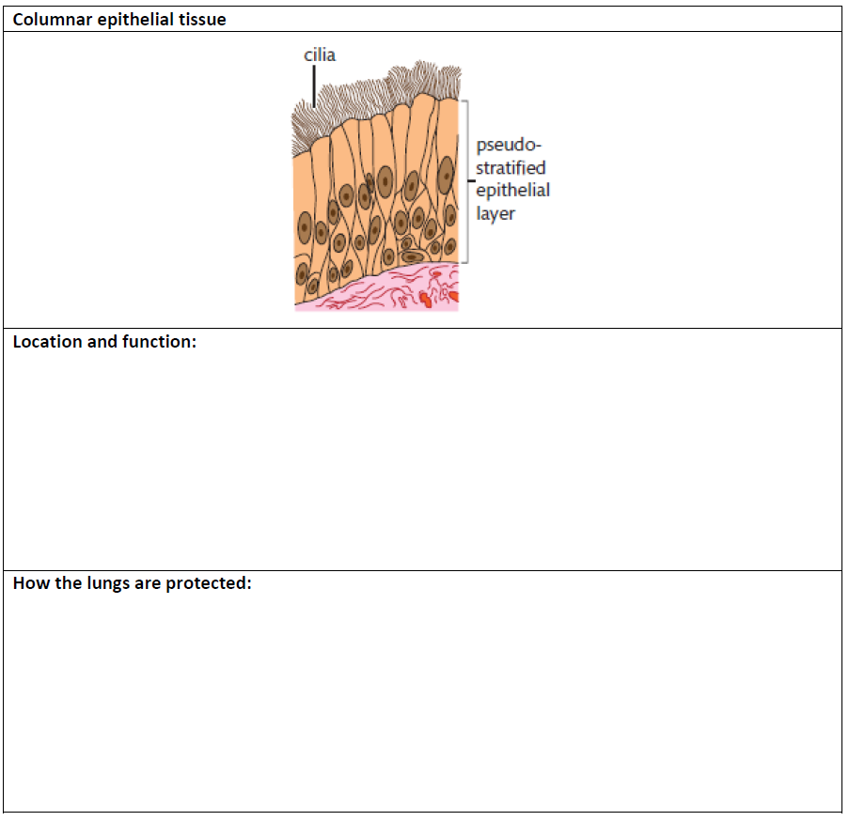

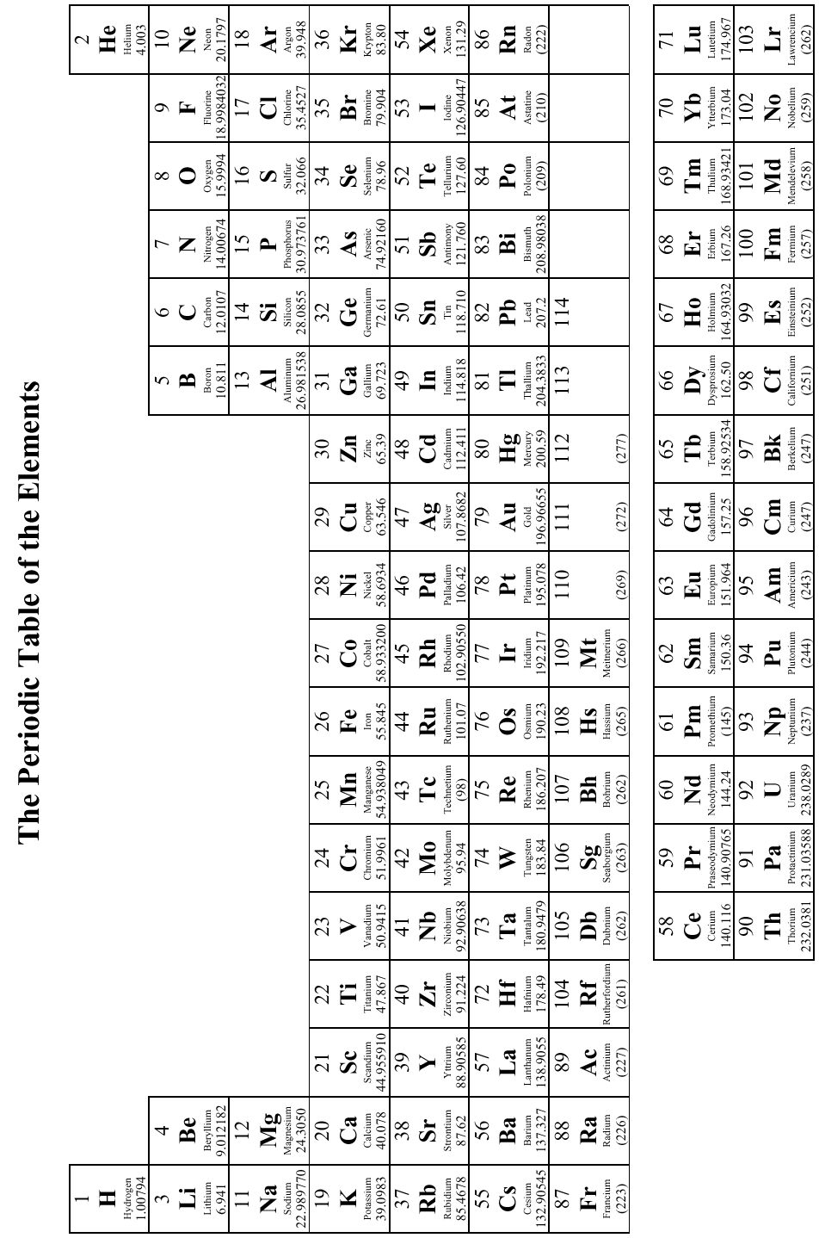

Periodicity and properties of elements

***The Periodic Table***

In year 11 you learn about the lay out of the periodic table and how it can be used to describe the atoms that make up different elements. You also learn about trends in group 1 and 7, we will build on this knowledge in year 12 to explain in detail why these trends occur and also to look at other trends in the periodic table you haven’t studied in year 11.

***Activity 1 – What do you know already?***

Complete the spider diagram below to show what you know about either Atomic Structure or the periodic table already from GCSE.

***Activity 2***

We will now focus on understanding atomic structure

1. Write down definitions for the following three important terms

**Atomic number_______________________________________________________________________________________________________________**

**Mass Number ______________________________________________________________________________________________________________________**

**Relative Atomic Mass ______________________________________________________________________________________________________________________**

1. Using what you should already know about the atom draw and label an atom in the space below that contains 2 protons, 2 neutrons and 2 electrons

Name the atom you have drawn _______________

1. write a paragraph below that summaries the structure of an atom.

________________________________________________________________________________________________________________________________________________________________________________________________________________________________________________________________________________________________________________________________________________________________________________________________________________________________________________________________________________________________________________________________________________________________________________________________________________________________________________________________

1. Pick any element off the periodic table and copy the information you can see into the box below ***exactly as you see it!*** Clearly label all the information so you know what it all means.
2. Use this information to work out the number of protons, neutrons and electrons in one atom of your chosen element. *HINT* you will need to round the atomic mass to the nearest whole number!

|  |  |
| --- | --- |
| Protons |  |
| Neutrons |  |
| Electrons |  |

***Activity 3 – Protons, Neutrons and Electrons***

You should now understand how to work out the number of protons, neutrons and electrons in one atom of any element. Use this knowledge to complete the table below

|  |  |  |  |  |
| --- | --- | --- | --- | --- |
| Element | Symbol | Protons | Neutrons | Electrons |
| Carbon |  |  |  |  |
|  | Mg |  |  |  |
|  |  | 78 |  |  |
|  | I |  |  |  |
| Copper |  |  |  |  |

In year 11 you learn how to balance equations, you are expected to be able to balance equations in year 12 (we will practice this again) and then we will build on this knowledge to work how many moles you find of a particular element in a formula so we can calculate theoretical yield. We will also recap calculating percentage yield.

***Equation writing***

Writing and balancing chemical equations is a fundamental skill for all scientists.

Equations show a chemist what will form during a chemical reaction.

Equations then need to be balanced in order to remain true with the basic law that atoms cannot be created or destroyed in a reaction, they are only rearranged.

Let’s attempt to balance an equation

Water is formed from the reaction of hydrogen and oxygen in the following equation: -

**H2 + O2 🡪 H2O**

Without balancing this equation it appears that one oxygen atom has been lost! This cannot happen. We must always end up with the same number of atoms after a reaction. So can we just write this: -

**H2 + O2 🡪 H2O2**

**NOOOOOOOO!!!!!!!** You can’t do this. The equation now balances but you no longer have water, you have made hydrogen peroxide!

When balancing equations it is essential that you **do not change the chemical formulae** of any reactant or product in the equation.

Let’s try this again…

**H2 + O2 🡪 H2O**

We know we need more oxygen on the product side. In order to do this I need to add another whole water molecule. This is what contains the extra oxygen

**H2 + O2 🡪 H2O**

**H2O**

Now I have in total 4 oxygen atoms on each side and they therefore balance. But by adding in another water, I have unbalanced the hydrogen atoms. There are 2 hydrogen atoms on the left hand side and now 4 on the right. This needs to be sorted! I can’t change the H2 to H4 so I must add another H2 to the left hand side.

**H2 + O2 🡪 H2O**

**H2** **H2O**

Finally to complete the balanced equation, I have to count how many of each molecule we have and write that number **in front** of the molecule (If there is only one, you don’t need to write ‘1’ you just leave it).

**2H2 + O2 🡪 2H2O**

**It’s as easy as that!!**

Try and balance the following equations. They get progressively more difficult so don’t panic if you can’t do some of them.

1. ___NaOH + ___H2SO4 🡪___Na2SO4 + ­­___H2O
2. ___SO2 + __ O2 🡪 ___SO3
3. ___Ca(OH)2 + ___HNO3 🡪 ___Ca(NO3)2 + ___H2O
4. ___ Mg + ___O2 🡪 ___MgO
5. ___Cl2 + ___NaOH 🡪 ___NaOCl + ___NaCl + ___H2O
6. ___C2H6 + ___O2 🡪 ___CO2 + ___H2O
7. ___C3H8O + ___O2 🡪 ___CO2 + ___H2O
8. ___C4H8O + ___O2 🡪 ___CO2 + ___H2O
9. Covalent Compounds

In year 11 you learn how to draw dot and cross diagrams to represent the electrons in the outer shell of elements and how they can either form covalent or ionic bonds, we will go over this again as it is part of the year 12 specification. See if you can have a go at the examples below. Remember your only drawing the electrons in the outer shell one element in the coupouns should be a dot and the other a cross.

Hydrogen

Oxygen

Carbon

Hydrogen

Hydrogen

Chlorine

Hydrogen

Hydrogen

Dot and Cross diagrams for Ionic Compounds

Magnesium

Oxide

Calcium

Oxide

Potassium

Chlorine

Chlorine

Sodium

Waves in communication

The physics section of the level 3 BTEC specification is all about waves, you will be expected to be able to use standard form and know the different units for speed and frequency of a wave. In year 11 you will have learnt how to be able to label a waves and calculate frequency etc… you will also have learnt about transvers and longitudinal waves. This also makes up part of the year 12 specification and we will build on this to learn some areas in more detail.

**Symbols and Prefixes**

|  |  |  |
| --- | --- | --- |
| **Prefix** | **Symbol** | **Power of ten** |
| Nano | n | x 10-9 |
| Micro | μ | x 10-6 |
| Milli | m | x 10-3 |
| Centi | c | x 10-2 |
| Kilo | k | x 103 |
| Mega | M | x 106 |
| Giga | G | x 109 |

Solve the following:

1. How many metres in 2.4 km?
2. How many joules in 8.1 MJ?
3. Convert 326 GW into W.
4. Convert 54 600 mm into m.
5. How many grams in 240 kg?
6. Convert 0.18 nm into m.
7. Convert 632 nm into m. Express in standard form.
8. Convert 1002 mV into V. Express in standard form.
9. How many eV in 0.511 MeV? Express in standard form.
10. How many m in 11 km?

**Standard Form**

At level 3 BTEC the quantity may be written in standard form, and it is expected that your answers will be too.

This means answers should be written as ….x 10y. E.g. for an answer of 1200kg we would write 1.2 x 103kg. For more information visit: [www.bbc.co.uk/education/guides/zc2hsbk/revision](http://www.bbc.co.uk/education/guides/zc2hsbk/revision)

1. Write 2530 in standard form.
2. Write 280 in standard form.
3. Write 0.77 in standard form.
4. Write 0.0091 in standard form.
5. Write 1 872 000 in standard form.
6. Write 12.2 in standard form.
7. Write 2.4 x 10 2 as a normal number.
8. Write 3.505 x 10 1 as a normal number.
9. Write 8.31 x 10 6 as a normal number.
10. Write 6.002 x 10 2 as a normal number.

**Waves**

You will have studied different types of waves and used the wave equation to calculate speed, frequency and wavelength in year 11. You will also have studied reflection and refraction. The BTEC physics topic is entirely about waves so it is important you refresh you knowledge on all of the areas above you studies in year 11 as they also make up part of the year 12 specification. In some areas we will build on your existing knowledge and learn in more detail about the behaviour of waves.

Use the following links to review this topic.

<http://www.bbc.co.uk/education/clips/zb7gkqt>

<https://www.khanacademy.org/science/physics/mechanical-waves-and-sound/mechanical-waves/v/introduction-to-waves>

<https://www.khanacademy.org/science/physics/mechanical-waves-and-sound/mechanical-waves/v/introduction-to-waves>

1. Draw a diagram showing the refraction of a wave through a rectangular glass block. Explain why the ray of light takes this path.
2. Describe the difference between a longitudinal and transverse waves and give an example of each.

________________________________________________________________________________________________________________________________________________________________________________________________________________________________________________________________________________________________________________________________________________________________________________________________________________________________________________________________________________________________________________________________________________________________________________________________

1. Draw a wave and label the wavelength and amplitude.