Art A’Level Transition Work
The first intense weeks of the A Level course focus on the drawing techniques of a range of artists and a lot of sketchbook work. In readiness for that work you should prepare some drawings that will be stuck into your Y12 sketchbook in September.
Task 1
Using materials that you think are appropriate, make one A4 drawing of the work of each of the following artists. You can also watch the You Tube clips to get ideas and work through the tutorials.
Norman Cornish https://www.youtube.com/watch?v=4SursKwIyWE
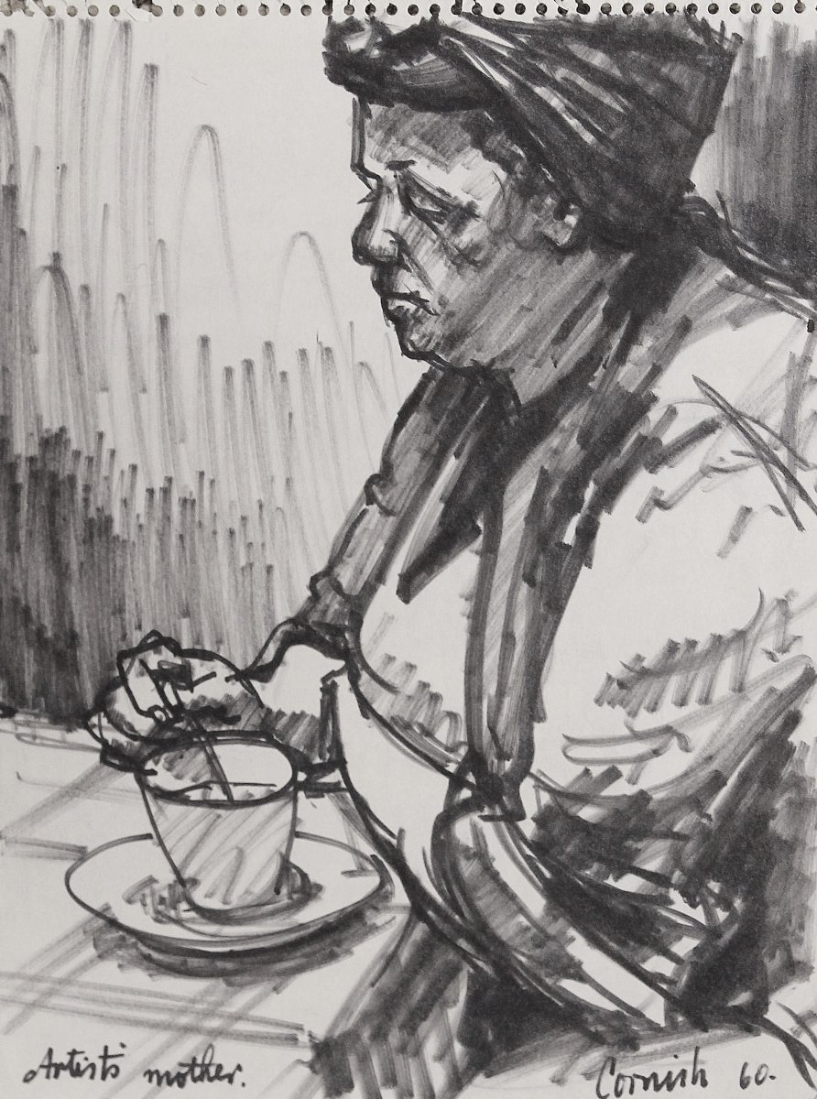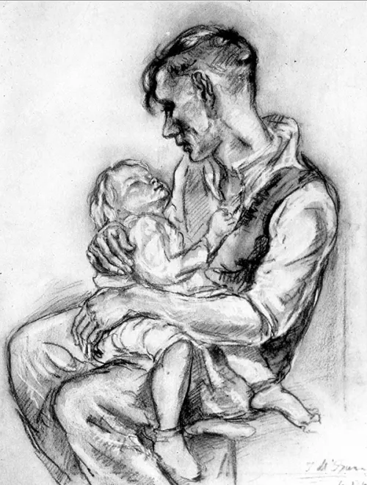
Suzannah Blaxill https://www.youtube.com/watch?v=6Ob_lM7YIDc

Henry Moore When you have drawn your copy of Moore’s drawing have a look at this clip https://www.youtube.com/watch?v=GLUW5trSLmc and make your own drawing of your hand.
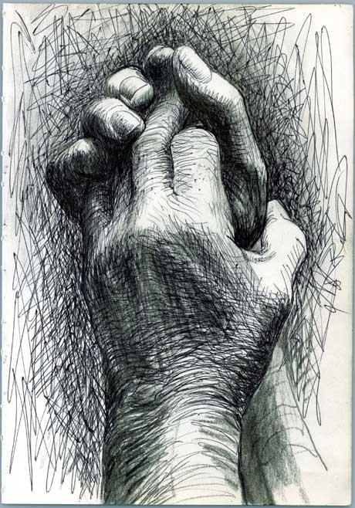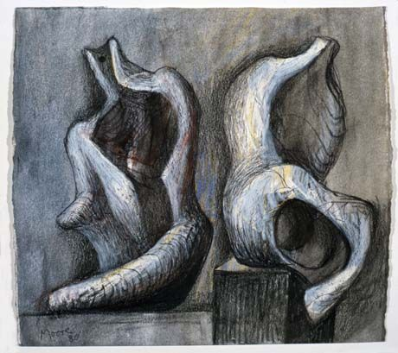

Task 2
Analyse each piece you copy using the following questions for guidance:
Who created this piece of work?
______________________________________________________________________________________________

What can you see?

_____________________________________________________________________________________________

How realistic is the piece? Is it abstract?

_____________________________________________________________________________________________

_____________________________________________________________________________________________

What materials do you think have been used?

______________________________________________________________________________________________

______________________________________________________________________________________________

How have the materials been used?

_____________________________________________________________________________________________

_____________________________________________________________________________________________

What colour scheme has been used and how does this affect you, the viewer?

_____________________________________________________________________________________________

_____________________________________________________________________________________________

When you study the piece, how does it make you feel? Happy, sad, confused?

______________________________________________________________________________________________

_____________________________________________________________________________________________

How do you think the artist was feeling when he/she created the work?

____________________________________________________________________________________________

____________________________________________________________________________________________

Do you think the piece has any hidden meaning that you don’t notice at first?
____________________________________________________________________________________________

Task 3 – Fun time!
Watch the You Tube clips below. Use them as inspiration to create your own interesting artwork from things you have lying around your house. You might use the bottom of a coffee cup to create stains on paper and build them up to form a new picture, or you could upcycle an item and create something new from it.
If the work you create is temporary, when you have created your piece take photographs of your work as a record.
If the work is permanent and small enough to bring into school then keep it to bring in in September.
Have fun!!

https://www.youtube.com/watch?v=jyEYgJNBUQU
https://www.youtube.com/watch?v=hewM1Qv5g9U
https://www.youtube.com/watch?v=dmPHZveFHWw
https://www.youtube.com/watch?v=l3GNWSnR514
https://www.youtube.com/watch?v=u7Rx0kRRZ-8

