Family Transition Handbook 2021
No child left behind. No family left behind.
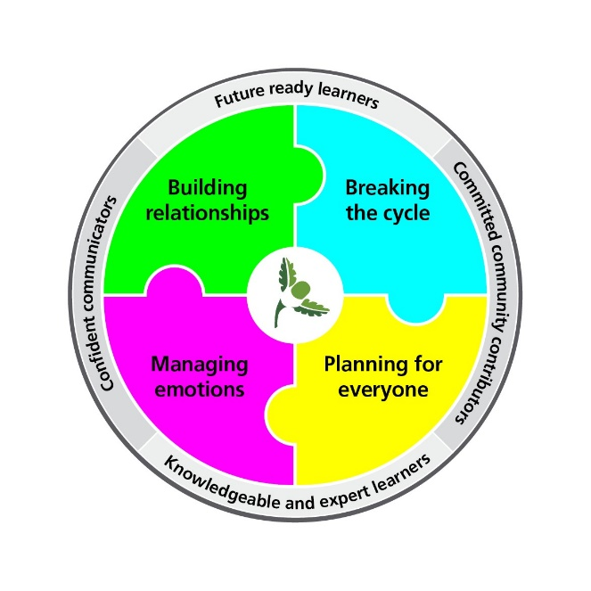
Headteacher: Tina Smith
Year 7 Team Leader: Linda Tomlinson-Askham
SENCo: Rob Slater
Email address: office@beckfootoakbank.org

Building relationships | Breaking the cycle |Planning for Everyone | Managing Emotions
Confident communicators |Knowledgeable and Expert Learners | Committed Community Contributors |Future-ready Learners

Contents

Welcome ……………………………………………………………………………………….2
Who knows my child? ………………………………………………………………………..3
Communications ……………………………………………………………………………...4
School Uniform ………………………………………………………………………………..5-7
School Books, Equipment and The School Day …………………………………………..8
Pledges …………………………………………………………………………………………9-10
Student and Staff Absolutes …………………………………………………………………11
Attendance …………………………………………………………………………………….12-13
Quality of Education ………………………………………………………………………….14-15
The Learning Planner ………………………………………………………………………..16
Home Learning ………………………………………………………………………………..17-18
Rewards and Student Leadership …………………………………………………………..19-22
Consequences ………………………………………………………………………………...23
Extra-Curricular Activities …………………………………………………………………….24
Student FAQs ………………………………………………………………………………….25
Financial Matters ………………………………………………………………………………26-30
School Facilities ……………………………………………………………………………….31
School Term and Holiday Dates 2021-2022 ……………………………………………….32
Notes ……………………………………………………………………………………………33

Welcome to Beckfoot Oakbank!
We are all so pleased that you are joining us in September 2021. A huge welcome from all of the staff and students at Beckfoot Oakbank. We are all looking forward to meeting you and starting the next part of the journey with you.

Starting at secondary school is a very exciting time and usually one that lots of children are ready for but we also understand that you and your child are probably feeling both excited and nervous about joining us in equal measures. We aim to make the transition from your Primary School to Beckfoot Oakbank as smooth as possible.

During May and June, I have been doing Zoom calls with all the students and their Y6 teachers. I have been struck by how keen they all are to come and meet us, by how smart they all were, by how polite they all are and by how inquisitive the children were! Their favourite question to me was ‘what food is there in the dining room?’! They also wanted to know about enrichment opportunities, what the science labs were like and what they do if they get lost. This booklet and Transition day should help to answer all of the questions that you have.

We know from experience that children are more likely to achieve their potential if they are content and comfortable in their surroundings, self-confident and well-motivated. And we also know the importance of a successful partnership between home and school in achieving this, so we actively encourage the support and input of all parents. You want to make sure that your child is happy, safe and learning skills to equip them for the future, and together we can make that happen.

We are very excited to welcome your child to Beckfoot Oakbank and hope their years spent with us are enjoyable and successful!

Tina Smith
Headteacher

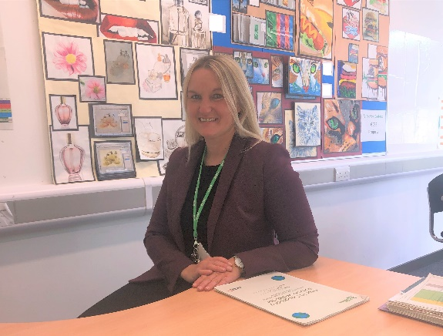
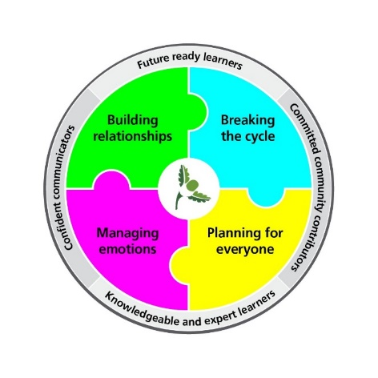

Who knows my child?

(email addresses: add @beckfootoakbank.org to the letters on the right)

Form Tutor: Their name is __________________________________________________

Headteacher  Associate Headteacher  Deputy Headteacher  Deputy Headteacher  Assistant Headteacher  Assistant Headteacher  Assistant Headteacher  Associate Assistant Headteacher/Post 16  Faculty Leader  Associate Assistant Headteacher/PE Faculty Leader  Associate Assistant Headteacher  Year 7 Team Leader  Assistant Year 7 Team Leader  Creative Arts Faculty Leader  English Faculty Leader  Humanities Faculty Leader  Languages Faculty Leader  Maths Faculty Leader  Science Faculty Leader  Technology Faculty Leader  SENDCO  Attendance Officer  Family Engagement Key Worker Y7  Safeguarding | Miss Smith  Mrs Hart  Mr Trueman  Mr Ray  Mr Coombes  Mr Hopkins  Mrs Walsh  Mr Delgado  Mr Heaton  Mr Moules  Mrs Tomlinson-Askham  Miss Lockwood  Mrs Ellwood  Ms Finlay/Miss Phillips  Ms Grayson  Mrs A. Walsh  Mrs Kerr/Mrs Greenhalgh  Mrs Humpherson  Mr Hill  Mr Slater  Mrs Scarborough  Mrs Hird  Mr Shearn | tsmith  lhart  oakgtr  oakcra  ccoombes  lh  awl  yd  ch  im  ltom  oakelo  ew  nf/sp  tg  oakawa  pkerr / tgreenhalgh  mhu  gh  os  ssc  ghird  tsh
Communications
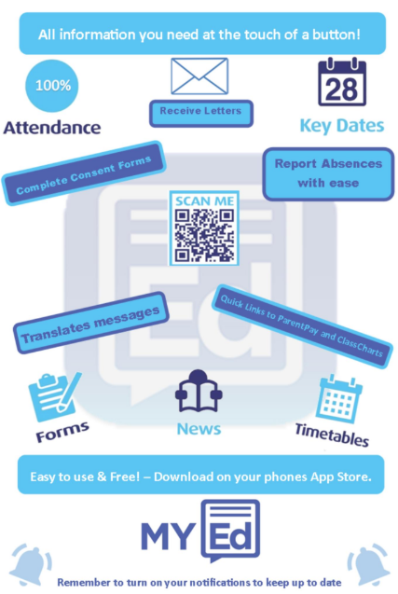
The School address is:

Beckfoot Oakbank School
Oakworth Road
Keighley
BD22 7DU

Telephone number:
01535 210111

Website: https://www.beckfootoakbank.org

Reception is open from 7:30am until 5:00pm Monday to Thursday and from 7:30 to 4:00pm on a Friday during term time.

Download the MyEd app to get all key information delivered straight to your phone or device.

Communications to School

For day-to-day matters: email or write to the Assistant Year Team Leader:
Miss Lockwood oakelo@beckfootoakbank.org

For more serious matters: email or write to the Year Team Leader:
Mrs Tomlinson-Askham ltom@oakbank.org

If you wish to see a member of staff please arrange an appointment, preferably by letter, or by telephone if urgent. It is often not possible for staff to see parents without a prior appointment.

Communicating Progress

We will provide information on your child’s progress during the year, through written reports and a parents’ evening. If you require duplicate reports, please contact the year team. You will also receive information through Classcharts, and the MyEd app.

It is essential that we have all contact details in order to get in touch in case of emergency. If you change your postal address, phone numbers or email address, please inform us immediately.

School Uniform Year 7 2021- 2022

Uniform can be bought at the following stores:

Whittaker’s School Wear and Top Trends in Keighley for PE kit, polo shirt, jumper and cardigan all with logo.
myclothing.com for the polo shirt, jumper and cardigan with logo.
Asda for trousers and skirts. Some families will be eligible for vouchers towards the purchase of uniform, please contact finance@beckfootoakbank.org for more information.
Plain  Polo t - shirt | All students should wear a polo shirt which is the correct colour for their year group. This must have the school logo  Year 7 = Black
Footwear | Black school shoes only (no trainers allowed). No high heels or boots  .
Trousers  Skirt  Tailored Shorts (after Easter only). | These should be plain black (no jeans, tracksuit bottoms, leggings or jeggings) with no accessories (frills, etc.). Plain belts are allowed.  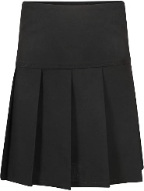  Pleated knee length skirts and black tights (No micro miniskirts or pencil skirts)  Black tailored school shorts may be worn by students after the Easter holidays.
 | Plain black Shalwar Kameez can be worn. If headwear is to be worn for religious or cultural reasons, it must be plain black.
Jumper or Cardigan | The school v-neck jumper is black and the cardigan is black, both must have the school logo embroidered on it.
Bag | All students must have a rucksack or appropriate school bag (not handbags) large enough for A4 folders, books, planner, writing and drawing equipment.  Must be big enough to place an outside jacket in as these will need to be put away on arrival, or you need to use a locker.
Physical Appearance | Discreet make-up only  No false acrylic /gel non removable nails.  No jewellery except one stud earring in each ear and a watch.  No facial piercings allowed or piercings in the tongue / gum.  Natural coloured hair, no bright colours or tram lines.
Badges | Only badges permitted to be worn on the school jumper / cardigan are the school star badges, attendance badges or leadership badges. Keep any other personal badges at home.
Mobile Phone | Mobile phones and any other forms of electrical devices are not permitted to be used during the school day. If they are brought in to school they must remain in the student’s school bag switched off until they have left the school building at the end of the day. Loss or damage of these prohibited items will not be the responsibility of the school.

Shoes should be black and of a formal style (that can be polished) with no decorative adornment e.g. studs. Trainers, shoes that resemble trainers, boots, canvas pumps or suede-styles are not acceptable.

PE Kit

Beckfoot Oakbank School P.E. kit is available from Whittakers Keighley.
Boys |  | Supplier
Shorts, black with Beckfoot Oakbank logo or track pants, black with Beckfoot Oakbank logo | Compulsory | Whittaker’ Schoolwear or Top Trends
Sports socks, red | Compulsory | Whittakers Schoolwear or Top Trends
Sports trainers with suitable ankle support  not plimsolls/Converse/Vans  not blades or moulded studs | Compulsory | Any supplier
Polo shirt, red and black with Beckfoot Oakbank logo | Compulsory | Whittakers Schoolwear or Top Trends
Reversible multisport shirt in black and red with Beckfoot Oakbank logo  Red hoodie with Beckfoot Oakbank Logo | Optional | Whittakers Schoolwear.or Top Trends
Girls |  | Supplier
Polo shirt red and black with Beckfoot Oakbank logo | Compulsory | Whittakers Schoolwear or Top Trends
Shorts, black with Beckfoot Oakbank logo or track pants, black with Beckfoot Oakbank logo  Skort, black with Beckfoot Oakbank logo | Compulsory | Whittakers Schoolwear or Top Trends
Sports socks, red | Compulsory | Whittakers Schoolwear or Top Trends
Sports trainers with suitable ankle support  not plimsolls/Converse/Vans  not blades or moulded studs | Compulsory | Any supplier
Quarter zip top black and red with Beckfoot Oakbank logo  Red hoodie with Beckfoot Oakbank Logo  Black leggings with Beckfoot Oakbank logo | Optional | Whittakers Schoolwear or Top Trends

Please note, we expect all students to participate in P.E. lessons either as a performer, coach, referee or scorer, therefore, kit must be worn at all times irrespective of illness or injury.

All clothing must be clearly marked with the student’s name.

We would recommend a mouth guard is used for all contact sports. Base layer
(skins) are also advisable during winter months.

If any parents are experiencing difficulties obtaining the uniform, please contact the
finance department.

School Books and Equipment

All students must have a rucksack or appropriate school bag (not handbag) large enough to carry A4 size folders. They must also have the following equipment:
- black fine liner, roller ball, gel or ink pen
- ruler
- eraser
- pencil sharpener
- pencil
- calculator
- pencil crayons

All textbooks, exercise books and folders must be looked after properly. Any student who causes damage to school property will be liable to a charge for repair or a replacement.

Lost Property

Students should make every effort to look after their property and should have their belongings clearly labelled.

Any items found will be taken to Student Reception where students can identify and claim back their belongings.

We ask that students do not bring items of financial or sentimental value into school. Loss or damage to such articles causes anxiety and distress. Neither the school nor the Local Authority has any insurance cover for the property and no payment can be made for loss or damage.

The School Day

The timings of the school day for Year 7 are:
 | Every Day
Arrive | 8:20am - 8:25am
Period 1 | 8:30am - 9:30am
Period 2 | 9:30am - 10:30am
Break & Tutor Time
Period 3 | 11:10am - 12:10pm
Lunchtime
Period 4 | 12:40 – 1:40pm
Period 5 | 1:40pm - 2:40pm

Together we pledge

Please read these pledges carefully, they outline our expectations for everybody in school.
As a world class learner, I embrace every opportunity to shape my development as a person, a future leader and a global citizen.
- I attend every day, and arrive on time to every lesson, wear my correct uniform and have my correct equipment.
- I take great pride in the presentation of all my work, including keeping my Learning Planner neat and up-to-date.
- I am a role model for and have the highest expectations for myself and my peers.
- I treat everyone and everything in my school community with respect, and respond first time, every time.
- I am resilient, reflective and highly ambitious about what I can achieve at Beckfoot Oakbank and in my future.
- I embrace all opportunities to prepare for my working life beyond Beckfoot Oakbank.
- I meet my home learning deadlines, revise thoroughly for exams and reflect on how to do even better next time.
- I use technology, the Internet and social media safely, appropriately and to enhance my learning.
- I ensure any letters or messages sent home are received by my parents/carers.

As a world class parent/carer, I am an active partner in my child’s learning.
- I have the highest aspirations for my child, and work in partnership with the school to ensure they fulfil their academic and social potential so that they are prepared for their life beyond Beckfoot Oakbank.
- I ensure my child attends and is punctual, and does not take family trips or holidays in term-time.
- I ensure my child is ‘school ready’ with the correct learning equipment and uniform.
- I support Beckfoot Oakbank practices, including those on behaviour and attitude to learning.
- I attend Parents Evening and any other meetings to discuss my child’s progress.
- I encourage my child to embrace opportunities to shape, enrich and lead their personal development.
- I encourage and motivate my child to seek out leadership opportunities and step out of their comfort zone.
- I support my child’s home learning and revision for exams by providing a suitable environment for them and checking their Learning Planner every week.
- I ensure my contact details are up-to-date and inform school of any changes.
- I take responsibility for any equipment, books or Learning Planner my child loses or damages.
As a world-class school, we put students first, nurture their talent and prepare them as future leaders.
- We provide a remarkable learning environment with a curriculum which is challenging, inclusive and forward thinking.
- We ensure teaching and learning is engaging, exciting and inspiring, and always seek ways to innovate.
- We see every student as an individual, and personalise our support and tutoring accordingly.
- We set challenging targets for individual students to aspire to and review them regularly.
- We empower students to pursue leadership opportunities, and provide enrichment activities which are varied, inclusive and fun.
- We prepare students for life beyond Beckfoot Oakbank, for entering the world of work and forging a career.
- We build confidence through recognising, rewarding and celebrating students’ success in all its forms.
- We communicate with parents/carers about their child’s individual progress through their books and reports home, and provide opportunities to talk.
- We share any concerns with parents/carers about their child’s individual attendance, behaviour or effort.
- We set home learning and revision which is meaningful and impacts on progress towards qualifications.

Student and Staff Absolutes

Our student and staff absolutes were created by students and staff to reflect what we want our school to be like, and what will help every student be as successful as possible. We have them displayed in all classrooms, and in shared spaces around school, and we use them to help us all remember how we need to behave day-to-day.
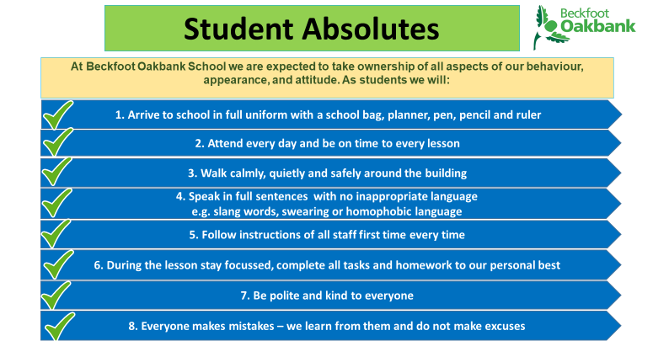
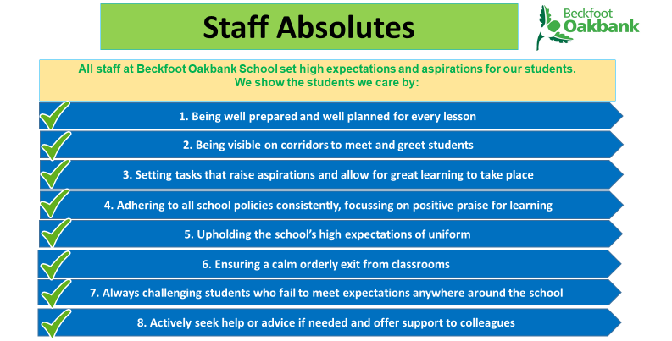

Attendance: Every Minute Matters

You’ve got to be in school to win school!

Attending school is not only a great way to see friends and get involved in extra-curricular activities, it is also vital to develop the skills and knowledge you need to be successful and happy in later life.

% attended
Grading over one Days lost Hours of
year per year learning lost
OUTSTANDING | 100% | 0 | 0 lessons  missed
EXCELLENT | 99% | 2 | 10 lessons  missed
EXPECTED | 97% | 6 | 30 lessons  missed
SATISFACTORY | 95% | 10 | 50 lessons  missed
CAUSE FOR CONCERN | 90% | 20 | 100 lessons  missed
SERIOUS CONCERN | 85% | 30 | 150 lessons  missed
 | 80% | 40 | 200 lessons  missed
SEVERE CONCERN | 70% | 60 | 300 lessons  missed

Punctuality

Punctuality to school is crucial. Students will be given a 1 hour after school detention if they are late three times in a week.

Students must arrive at school and enter through their designated entrance before 8.25 a.m. Students who arrive after this are late and will need to sign in at Student Reception, or present a note from a parent/carer, or medical evidence, to explain lateness. Students must also arrive at lessons on time.
Punctuality to school is crucial. Students will be given a 1 hour after school detention if they incur more than three in a week.

Absence
If your child is unable to attend school for any reason you must contact school (telephone or MyEd app) to explain the situation; this message will then be logged on your child’s attendance record.
On returning to school, your child must bring a note and any medical evidence you may have to authorise the absence.
Please remember that early morning aches and pains often pass, and children should not stay at home ‘just in case’, when they could be learning in class. According to NHS guidance, children do not require time off school for the following: cold; cold sores; conjunctivitis; cough; glandular fever; hand, foot and mouth; headache; head lice; sore throat; threadworms; tonsillitis; warts and/or verrucae. However, you should seek medical treatment where necessary.
Illness and Accidents
If your child feels unwell or has an accident in school, they should tell a member of staff straight away. A trained first aider will take care of them. If they are too ill to remain at school or if hospital treatment is needed, you will be contacted and suitable arrangements made. Under no circumstances should students leave school or go home without permission.
Holidays

Taking time off for holidays interferes with childrens’ learning and progress. Academic results may be affected through missing important exams or assessments. No leave of absence for holidays will be granted during term time. If your child has time off for a holiday, the absence will be unauthorised and you will be fined. If your child needs an absence for any other reason, you must complete an absence request form and return this to school at least two weeks prior to the absence.

From 2015, the government reduced the persistent absence threshold from 15% to 10%. Therefore, a student is considered to have persistent absence if their attendance falls below 90%. This is the equivalent of one day off every fortnight.

Quality of Education – The Curriculum

We have spent a great deal of time developing our curriculum so that we are able to develop young people as they progress through their journey at Beckfoot Oakbank. The coloured jigsaw pieces represent our contextual drivers. They are the cornerstones of our work around curriculum that will enable us to deliver the four ambitions of our curriculum. We aim to inspire learners to be confident communicators, knowledgeable and expert learners, committed community contributors and future-ready young people.

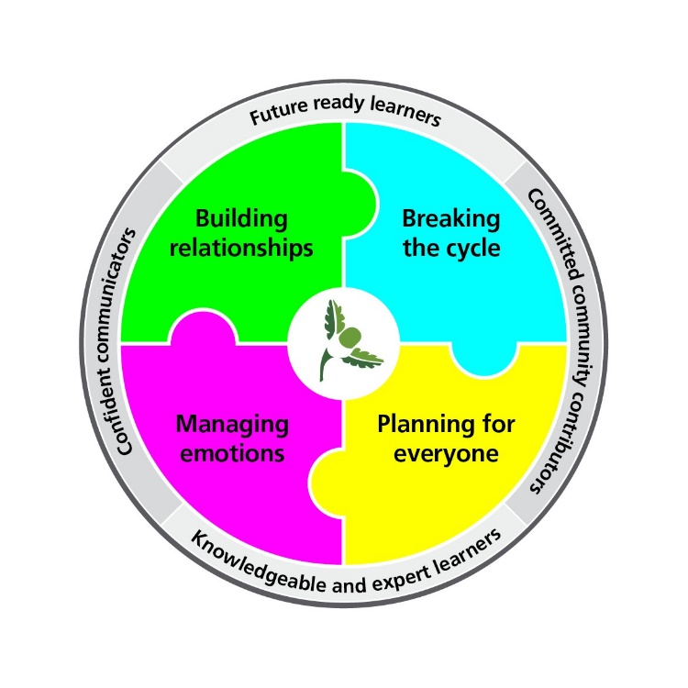

In Key Stage 3 , years 7, 8 and 9, Beckfoot Oakbank students are taught subjects aligned to the National Curriculum, including English, Maths, Science, Geography, History, French, Art, Drama, Music, Technology, Computer Science and PE. They also receive one lesson a week of ‘Open Minds’, a subject designed to provide knowledge about themselves and the world around them, outside of the more traditional school subjects.
Our teachers are passionate about their subject areas and work hard to plan and deliver lessons that not only help students develop the knowledge and skills they need to be successful, but to enjoy doing so.

Quality of Education – Assessment

At Beckfoot Oakbank we expect the best from all our students in everything they do. As part of this students are expected to revise and try their hardest for all assessments at school.
Most assessment is ongoing and used by teachers to identify what students know well and what they might need more practice or support with. This happens in lessons as quizzes and recall activities and may also form part of the home learning that students are expected to complete.
Baseline Assessments
In Year 7 students complete baseline assessments in September to help place them in the correct sets for many of their subjects. These are not permanent sets and students will have opportunities for sets to be reviewed.
Further Assessment
At various points throughout Key Stage 3 we will complete more formal assessments. These will require students to prepare well and recall their prior learning at school, including from previous years as they move up into Year 8 and Year 9.
Supporting retention and recall of learning
To support all students to retain their learning subjects will provide students with a knowledge organiser (see example from geography below) that contains the key knowledge and vocabulary for each unit.

In preparation for the assessments students may also be provided with a revision pack and guidance on how to revise. They will also be receiving guidance through tutor time about using their knowledge organisers to retain learning effectively.
Increasingly we will be developing our use of the website to share curriculum information with families. We will outline the details of any assessments and provide clear and practical guidance on how to support your child to produce their best. We know that getting into good habits early on at high school strengthens success when it comes to GCSE and A-Level exam time.

The Learning Planner

Every student has a Learning Planner from their first day at school. It is used to organise and record a range of information, including communications between home and school, and is a crucial part of school equipment.
It should be:
1. Brought to school every day and placed on the desk in every lesson.
2. Used to record home learning tasks.
3. Used to record ingredients or equipment needed for future lessons.
4. Used to communicate between teachers, tutors and parents.
5. Checked and signed by a parent or carer on a weekly basis.
6. Replaced if lost at home or school.

Home Learning

Home learning is used to supplement in school learning and will be set in a range of ways including using Microsoft Teams. There are short guides available on the website for families to help you to understand how to use Microsoft Teams.

- All students will also record home learning tasks in their Learning Planner.

Monitoring of home learning
- ‘Positive Classroom Conduct’ for completion of home learning will be Class Charts stamps. Other recognition may include: positive praise, postcards, email, text or phone call home, positive comment in learning planner or homework hero stickers.
- If a lack of engagement becomes an issue then the first wave of intervention is from the classroom teacher e.g. discussion with the student, phone call home etc. If required then this would escalate to faculty level intervention e.g. faculty report card, letter sent home etc.
- We will aim for the Learning Resource Centre to provide daily clubs from 2:45pm-3:30pm to support Home Learning so students have a supportive environment in school to learn beyond the classroom.
- Successes and concerns will be communicated with key stakeholders including students/parents/tutors.

What do I need to know about Home Learning? Student FAQs

How do I log on to Teams?
Microsoft Teams | Group Chat, Team Chat & Collaboration
- Select “sign in”
- Enter your school username and password
- Select the class team to find your homework.
- You will be shown how to do this during the first two weeks in school in September.

How do I log in to Classcharts?
www.classcharts.com/student/login
- Input your student code and your date of birth to log in to your Class Charts account to view your home learning rewards.
- If you do not know your student code then you can request this from your form tutor or year team.

How do I log in to MyMaths?
- www.mymaths.co.uk
- School login: oakbank School password: obtuse
- You will receive a personal login and password too, so your teacher can set you specific topics, and you can track your progress.

What do I do if I need help?
- Email your teacher from your school email address (see below for instructions).
- Go onto your email account and click on “new message”, in the “To” box type in your teacher’s surname and their email address will appear , you may need to scroll down a few alternatives to find it.
- You will be shown how to do this during your first two weeks in school in September.
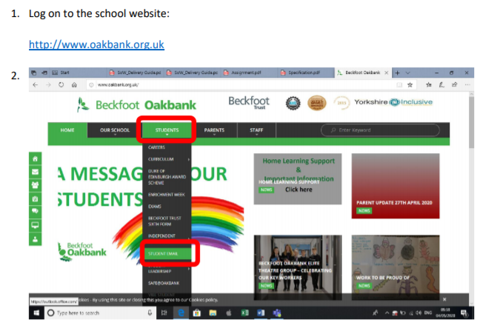
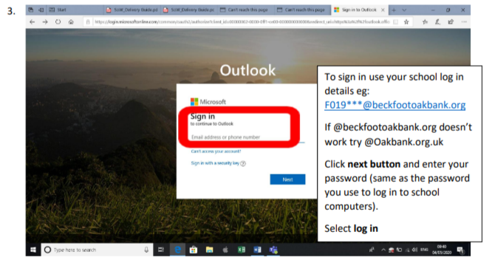
Rewards

Students are awarded stamps during the school day which are recorded on Class Charts. These stamps are monitored and can lead to specific rewards including access to Student Leadership.

- Celebration Assemblies
- End of Year Celebration Evenings
- Half termly Cinema Events (97%+ Attendance and 90%+ Positive Behaviour)
- Supporting Sports Teams & Extra Curricular Events
- Access to Enrichment Activities e.g. Drop Down Days & Trips
- 3 Star, 4 Star & 5 Star Badges
- Year Team Rewards
- Stamps & Certificates
- Star of the Month
- Tutee of the Week

Student Leadership at Beckfoot Oakbank
The student leadership offer at Beckfoot Oakbank:
- Students make a committed contribution to the school and society who own their learning experience.

- Students earn the esteem of others and have the belief that they can change things for the better.

- Students develop skills that make them ready for success in the future.

Student Leadership will be linked into the whole school rewards policy so students earn the right to be a student leader. The rewards policy for stamps is below:
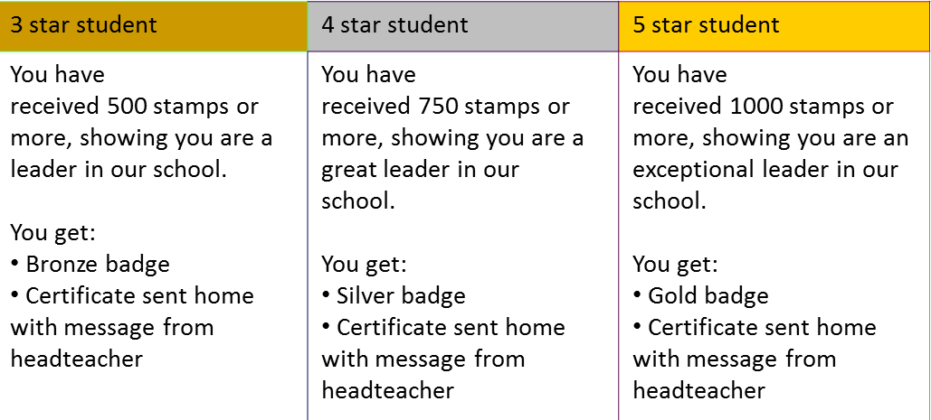

Star badges are awarded to students based on their achievement. Once a student reaches the 3-star Bronze badge they will be invited to be part of one of the student leadership teams below that will help improve the school. Any student who reaches the 5 Star Gold Badge, will be invited to sit on the student leadership board.

Student Leadership Board
Made up of a senior team consisting of students who have achieved 5 Star Gold Badge. Will debate key ideas and issues from each strand within Beckfoot Oakbank on a monthly basis with Mrs Berry alongside discussing proposals at SLT.
Events Team | Health and Wellbeing Team | Voice Team
Contribution to Beckfoot Oakbank events, such as charity days, evening events, whilst promoting wider community events in school. | To improve the physical, mental and social wellbeing of students and to promote a healthy and active lifestyle. Also involved with the school’s Anti-Bullying Ambassadors. | Develop the school based upon the views of students. Opportunities to be learning leaders and shape their learning experience. Help to raise issues within both Beckfoot Oakbank and the local community.

Below is a summary of the responsibilities each of the strands have in school life:
Events Team
- Supporting school events (evening) in the marketing and promotion of school within the community.
- Plan and support charity events that Beckfoot Oakbank can get involved in.
- Promote events happening in the local community that Beckfoot Oakbank can help participate in.
Health and Wellbeing Team:
- Promotion of healthy living and sport participation in and out of school.
- Promotion of Duke of Edinburgh award scheme. Be heavily involved with Sports Day.
- Work closely with the school’s Anti-Bullying Ambassadors and Wellbeing team.
Voice Team
- Collect student voice to raise issues in the school and the wider community.
- Run Votes for Schools agenda for the tutor programme and use it as a vehicle for positive change.
- Working with faculty areas shaping their learning experience.
- Create a ‘you said, we did’ display each term.

Student Leadership Board:
- Meet with Mrs Berry once a month to discuss and debate key ideas and issues from the three strands. Present ideas / proposals to SLT and hold assemblies.
- Responsible for the display and marketing of student leadership across Beckfoot Oakbank.
- Promote the student leadership offer at all levels within school by being role models.

All 3 star Bronze badge and above student leaders will be available for the school’s interview process and showing visitors around school.

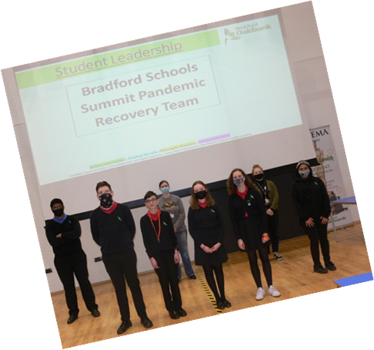
Here are some of the events that have taken place because of student leadership.
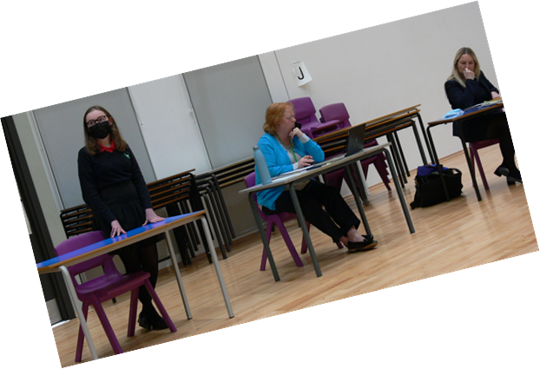
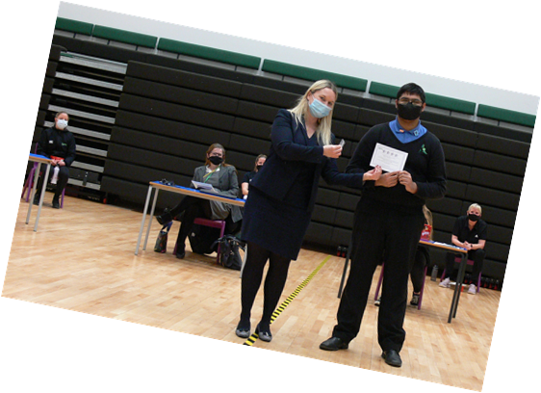
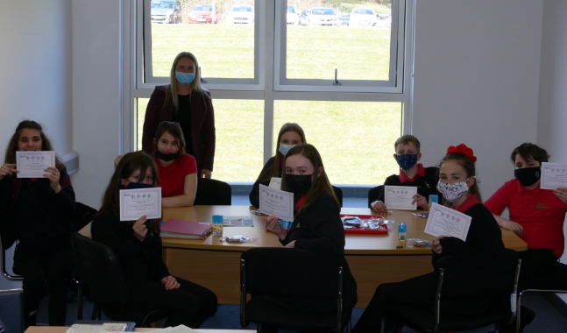
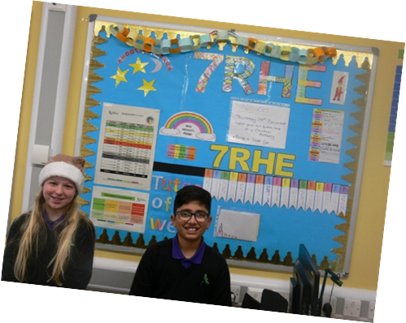

Consequences
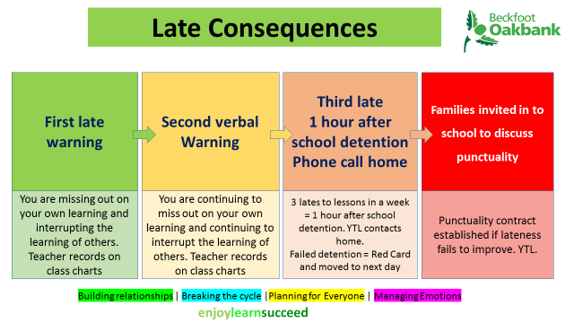

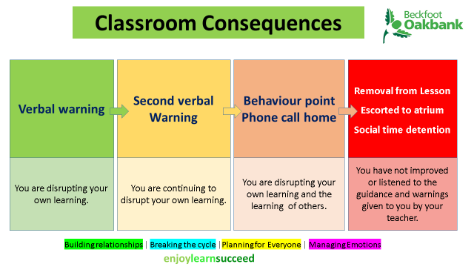

Extra-Curricular Activities

As well as the academic things children will learn and the friends they will make, there are plenty of opportunities for them to develop new interests and improve on the ones they already have. There are plenty of extra-curricular activities to get involved with. At the start of the term, students are given the chance to sign up for after school and lunchtime activities.

Previous activities have included:

- art club
- humanities club
- football
- basketball
- samba band
- choir
- guitar group
- cricket
- netball
- orchestra
- badminton
- cheerleading
- science club
- drama club
- rugby
- table tennis

Students can always take the initiative and approach a member of staff if they are keen to get involved in a club that doesn’t currently exist

Student FAQs: What should I do if…?

I have lost something. | Lost property is kept in Student Reception. If you have lost something, tell your year team.  ALL property should be clearly marked with your name.
I have forgotten homework/  P.E. kit/essential equipment. | Apologise to your subject teacher, before the lesson if possible, or at the start. For P.E. borrow some kit from the P.E. office.
I am being bullied or know someone who is. | Tell somebody – inform your form tutor, year team, a teacher or a friend. Do not keep it to yourself.
I do not feel well. | Tell your teacher. They will arrange for you to see a first aider in Student Reception.
I have to take medication. | This should be clearly labelled with your name and given to Student Reception who will keep it safely until you need it. The only exceptions are; if you have an inhaler for asthma: you should keep one inhaler with you, a spare inhaler can be kept at Student Reception if necessary. If you require an adrenaline auto injector for allergies: you should keep one with you, spares can be held at student reception if necessary.  Your parent/carer will also have to sign a consent form, which can be collected from Student Reception.
I have lost my planner. | Get a note from your tutor to explain that this is lost. Replacements cost £1.85 and can be purchased on ParentPay and collected from Student Reception.
I do not have correct uniform. | Bring a note from home to explain why. Go to Student Reception where you can borrow the items you need.
I have forgotten my locker key. | Go to Student Reception at break or lunch.
School closes unexpectedly. | If the closure is due to adverse weather do not ring school. Please listen for announcements on Radio Leeds, Pulse Radio and check the school website: www.beckfootoakbank.org and the school Twitter Feed: @BeckfootOakbank  The school will make every effort to contact parents/carers via text message should it become necessary to close early, so please check your details are up to date and correct.  Parents/Carers: please make sure that your child is aware of what they should do if school were to close early i.e. walk straight home with friends, get a bus straight home, go to a relation’s/neighbour’s/friend’s house. It would be advisable to ensure that your child has clothing and footwear suitable for this journey.

Financial Matters Please email finance@beckfootoakbank.org if you have any questions.

Cashless Catering
The school operates a cashless payment system. There are many benefits of cashless systems relating mainly to an improvement in the speed and level of service we provide in our catering outlets and, in addition, those students who receive free school meals are able to do so without their fellow students being aware of this. If you think your child may be eligible for free school meals, please register with the local authority as soon as possible for more details about the benefits of registering for free school meals.

https://online.bradford.gov.uk/ufs/FREE_SCHOOL_MEALS.eb?ebd=0&ebp=10&ebz=1_1586344741665
The cashless system shares a common biometric database across school as explained in the biometric information section.

There are two ways in which students or their parents/carers can credit individual student accounts for purchasing meals:

- by cash (coins and notes) into one of two revaluation units around school (student access only)
- online using ParentPay, which is an easy, electronic method similar to internet banking, transferring payments directly from your bank account to the school’s bank account, for your child’s school meals, etc.

Further details on all payment methods are available from the school Finance Office.

Catering accounts can be credited on a daily, weekly, monthly or termly basis and as a parent/carer you can let us know if you would like to limit the way in which your child will spend this money. For example, you may wish your child to purchase items at breakfast, break and lunchtime or perhaps at lunchtime only. If you pay in advance, you can also limit the amount your child spends on a daily basis. For example, if you transfer £15 for one week of school meals it would be sensible to indicate a daily spend limit for your child of £3 per day. Your child will be able to view the balance on his/her school meals account at the revaluation units around the school and at one of the till points during the meal service period.

When your child buys something from a catering outlet the cost is charged to their account. Those parents/carers who use the ParentPay option are able to view, online via their account, the amount their child has spent and on what type of purchase. If you do not use the ParentPay option, you will be able to request details via the school, however, it may take a few days to produce a paper copy of this.
For queries about catering, please email the Catering Manager at ddavis@oakbank.org.uk.

The ParentPay form and further information were contained in the Permissions Booklet you have already received.

Intent to Process Pupils’ Biometric Information

Under the Protection of Freedoms Act 2012 (sections 26 to 28), we are required to notify each parent of a child and obtain the written consent of at least one parent before being able to use a child’s biometric information for an automated system.

Biometric information and how it will be used

Biometric information is information about a person’s physical or behavioural characteristics that can be used to identify them, for example, information from their fingerprint. The school would like to take and use information from your child’s fingerprint and use this information for the purpose of providing your child with access to the library book lending service, computer printing and cashless catering.
The information will be used as part of an automated biometric recognition system. This system will take measurements of your child’s fingerprint and convert these measurements into a template to be stored on the system. An image of your child’s fingerprint is not stored. The template (i.e. measurements taken from your child’s fingerprint) is what will be used to permit your child to access these services.

You should note that the law places specific requirements on schools when using personal information, such as biometric information, about pupils for the purposes of an automated biometric recognition system.

For example:

- the school cannot use the information for any purpose other than those for which it was originally obtained and made known to the parent(s) (i.e. as stated above);

- the school must ensure that the information is stored securely;

- the school must tell you what it intends to do with the information;

- unless the law allows it, the school cannot disclose personal information to another person/body – you should note that the only person/body that the school wishes to share the information with is the supplier of the biometric system. This is necessary in order to maintain the system and provide updates to the software as appropriate.

Providing your consent/objecting

As stated above, in order to be able to use your child’s biometric information, the written consent of at least one parent is required. However, consent given by one parent will be overridden if the other parent objects in writing to the use of their child’s biometric information. Similarly, if your child objects to this, the school cannot collect or use his/her biometric information for inclusion on the automated recognition system. You can also object to the proposed processing of your child’s biometric information at a later stage or withdraw any consent you have previously given. This means that, if you give consent but later change your mind, you can withdraw this consent. Please note that any consent, withdrawal of consent or objection from a parent must be in writing.

Even if you have consented, your child can object or refuse at any time to their biometric information being taken/used. His or her objection does not need to be in writing. We would appreciate it if you could discuss this with your child and explain to them that they can object to this if they wish.

If you do not wish your child’s biometric information to be processed by the school, or your child objects to such processing, the law says that we must provide reasonable alternative arrangements for children who are not going to use the automated system to access the services provided by it.

The consent form for the processing of your child’s biometric information was included in the Permissions booklet you have already received.

Thank you for your co-operation in this matter and for helping us to maintain a safe and efficient system for our students. If you do not wish to provide consent for the biometric system, we will issue your child with a PIN number, however this is not as secure as the biometrics. This number must not be shared with anyone else in school.

Charging Policy

All education during school hours is free of charge. We do not charge for any activity undertaken as part of the national curriculum.

Voluntary Contributions

When organising school trips and visits which enrich curriculum and educational experience for students, we invite parents/carers to contribute to the cost of the trip. All contributions are voluntary. If we do not receive sufficient contributions we may cancel the trip. If the trip goes ahead, it may include students whose parents/carers have not paid the full contribution. Information is available on request for those parents seeking financial support. The following is a list of additional activities that may be organised by the school which require voluntary contributions from parents/carers:
- visits to museums
- sporting activities which include transport expenses
- outdoor adventure activities
- visits to theatres
- musical events

Residential Visits

If the school organises a residential visit in school time or out of school time, which is to provide education directly related to the national curriculum, we do not make a charge for the education aspect. However, we do make a charge for the board, lodging and travel expenses (except in the case of students who are entitled to free school meals when the residential trip takes place, who will not have to pay for board and lodgings). If the visit takes place out of school hours and/or term time, and is not related to the curriculum, the school will not subsidise any part of the trip.

Music Tuition

All students study music as part of the normal school curriculum. We do not currently charge for this. Individual or small group music sessions are available outside of the normal school curriculum. These places are limited in number. If a student does not regularly attend these sessions, they will be required to relinquish their place in favour of the next student on the waiting list.

Exam Fees

We do not charge for exam fees as part of the normal curriculum. Where students wish to re-sit their exams in order to obtain an improved grading, a charge of the full exam entry fee will be made in advance of the entry. If the student receives an improved grade, the exam fee will be reimbursed at a later date.

A charge will be levied where a pupil fails without good reason to complete the requirements of any public examination where the school paid or agreed to pay the entry fee. Late entry or amendment fees are paid by the subject department or candidates.

Candidates must pay the fee for an enquiry about a result, should the centre not uphold the enquiry and the candidate insist on pursuing the enquiry.

Lockers

Lockers are available for all students. Those students who wish to use a locker will be charged a one-off charge of £5.00 (non-refundable). Replacement keys will be charged at cost. Parents who wish for their child to have a locker should contact the finance department.

Library Books

Library books are available to borrow from the Learning Resource Centre for academic study or reading for pleasure. In order to provide a wide range of reading opportunities it is vital that all borrowed books are returned and in a timely way. We do not charge students for the use of the library facility, however, lost books will be charged at the cost of the replacement book.

Materials and Textbooks

Where a student or parent wishes to retain items produced as a result of art, craft and design, or design and technology, a charge may be levied for the cost of the materials used. In the case of food technology, school provide some of the ingredients for years 7, 8 and 9. If a student chooses the food technology option for year 10 onwards, they would usually be expected to provide their own ingredients. Textbooks are provided free of charge, but in some subjects, additional revision guides are available, for which a charge is made.

Damage/Loss to Property

A charge will be levied in respect of wilful damage, neglect or loss of school property (including premises, furniture, equipment, books or materials), the charge to be the cost of replacement or repair, or such lower cost as the Headteacher may decide.

School Facilities

School Transport | In previous years, parents have been required to complete an application to use a school bus service. Due to Covid-19, please contact  www.wymetro.com/schools to enquire about this service.
Catering | Breakfast  Break  Lunch  For catering account queries, please email the Catering Manager at ddavis@oakbank.org.uk.
Fitness Room | This room contains various items of equipment for developing general fitness and muscle strength. The facilities may only be used under supervision: details will be published at the start of the year.
Learning Resource Centre | The LRC is open all day, including before school, at break and lunchtime, and after school, and stocks a huge range of fiction and non-fiction. It also has a suite of computers available for students to complete home learning tasks. Students will visit as part of English lessons, but are welcome to pop in during social times too.  The LRC is run by Miss King with the help of student assistants who work in the LRC at break and lunchtimes. There are opportunities to apply for one of these roles during the year.  Students receive an induction during the first few weeks of school, which will help them understand how to get the best out of the LRC in their time at Beckfoot Oakbank.

School term and holiday dates 2021-2022

AUTUMN TERM 2021
Monday 6th September 2021 | Training Day | Closed to students
Tuesday 7th September 2021 | Training Day | Closed to students
Wednesday 8th September 2021 |  | Open
Friday 22nd October 2021 | Half Term | Close at 2:40pm
Monday 1st November 2021 |  | Open
Friday 26th November 2021 | Training Day | Closed to students
Friday 17th December 2021 | Christmas | Close at 2:40pm

SPRING TERM 2022
Monday 3rd January 2022 | Bank Holiday | Closed
Tuesday 4th January 2022 |  | Open
Friday 18th February 2022 | Half Term | Close at 2:40pm
Monday 28th February 2022 |  | Open
Friday 8th April 2022 | Easter | Close at 2:40pm

SUMMER TERM 2022
Monday 25th April 2022 |  | Open
Monday 2nd May 2022 | May Day Bank Holiday | Closed
Tuesday 3rd May 2022 |  | Open
Friday 27th May 2022 | Spring Bank Half-Term | Close at 2:40pm
Monday 6th June 2022 |  | Open
Thursday 21st July 2022 |  | Close at 2:40pm

Notes

Use this space to write down any questions you have

