Business Studies

Home Learning Pack
Challenges

Please find attached a pack of work to help prepare you for Sixth Form.

I am delighted that you have shown an interest in Business Studies. In order to get you thinking about the subject, I have put together some information and activities to help you prepare for studies in the 6th form such as business research activities, books to read, films to watch on a rainy afternoon, useful websites to browse when Snapchat, Instagram gets dull.

For a look at the syllabus:
- BTEC Business Specification
- https://qualifications.pearson.com/content/dam/pdf/BTEC-Nationals/Business/2016/specification-and-sample-assessments/9781446938218_BTECNationals_Bus_ExCert_Spec_Iss3C.pdf

Useful websites/apps- register now:
- Register with http://www.tutor2u.net, a Business Studies blog especially written for students. A daily blog will be sent to you with interesting news articles that tie into the syllabus, comments from examiners and (later) tips and support for exam modules

- For (business) news stories use the BBC website http://news.bbc.co.uk

Please email me at jgreenwood@oakbank.org.uk if you have any queries or questions.

In the meantime, I want to say a big thank you for your hard work in Year 11 and I am so very sorry you have lost your opportunity to complete the exams. During these unprecedented times it is important to keep going and know we will be back to normal soon.

Kind regards

Mr J Greenwood

Links to Level 3 BTEC Business

Below are topics you have studied in Y10 and Y11 which will also appear in Year 12 and Y13

Component 1 and 2 – Coursework Units

- Business Ownership – e.g. Sole Trader, Partnership, Public Limited Company
- Aims and Objectives
- Characteristics and Skills of entrepreneurs
- Market Research – e.g. Primary and Secondary research methods
- Target Market – looking at different types of customer to attract
- Analysing Rivals – e.g. price, quality, availability, unique features and selling points (USP)
- Marketing – e.g. different methods and their effectiveness
- Human Resources – e.g. Staff levels, training etc
- External Factors – e.g. Interest rates, inflation, social trends, levels of disposable income
- Communication Methods – e.g. traditional and modern ways like letter and email
- Location
- Financial Information

Component 3 – Exam Unit

- Advertising methods - e.g. moving image, print, digital, audio
- Sales promotion – e.g. coupons, competitions, money off
- Target Market – e.g. age, race, gender, family size, ethnicity
- Payment methods – e.g. cash, credit cards, debit cards, direct debit, payment technologies
- Start-up costs and running costs
- Statement of comprehensive income - shows the profit or loss of an enterprise over time
- Statement of financial position - shows the financial performance of an enterprise at a point in time
- Terminology in financial statements
  - Turnover
  - cost of sales (cost of goods sold)
  - Gross profit, expenses, net profit, retained profit
  - Fixed assets and current assets
  - Current liabilities and long-term liabilities
  - Debtors and creditors
  - Liquidity
  - Profitability
- Cash Flow Forecast
- Break Even Analysis
- Costs – e.g. variable costs, fixed costs, total costs
- Sources of finance
  - owner funds
  - retained profits
  - loans
  - credit cards
  - government grants
  - hire purchase and leasing
  - trade credit
  - venture capital
  - peer-to-peer lending.
Key Words to define

Sole Trader
Public Limited Company
Public Sector
Private Sector
Not for profit business
Primary Sector
Secondary Sector
Tertiary Sector
Stakeholder
Shareholder
Aim
Objective
SMART Objective
Flat Organisational Structure
Hierarchical Organisational Structure
Human Resources
Marketing
Purchasing
Customer Service
Inflation
Interest Rates
GDP
Business Ethics
Monopoly
Oligopoly
Supply
Demand
Price elasticity of demand
Innovation

Activities

“A week in Business”.
1 | Select 7 pictures, one for each day to represent a business news story. ( see if there is something different happening not just Coronavirus)
2 | For each story, write a commentary/explanation:  - What is happening  - What has it got to do with business  - Why is it important?
3 | Select the story that you found most interesting. Why was this?
4 | Create a poster showing your pictures

Choose a Company/brand and research it!
Find out the following – Ownership type, Revenue, Profit, Number of employees, size and scale, name of leader (CEO)

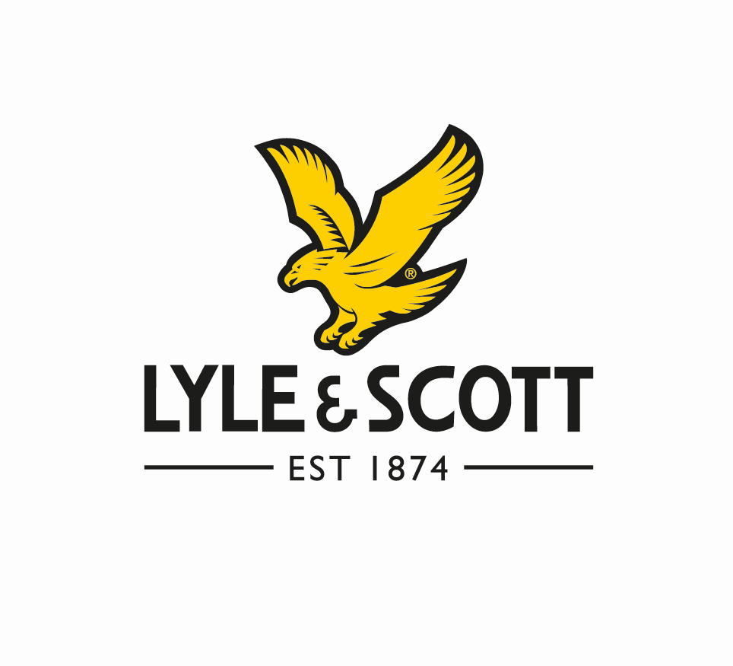
Entrepreneurs and Leaders

Research these business people

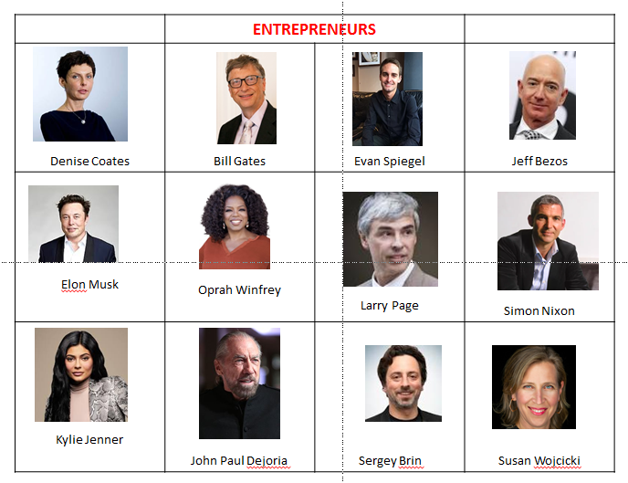

Research these different entrepreneurs and find out the following: -
- What have they done?
- Why are they an entrepreneur?
- How did they do it?
- What is their net worth?

Research Activity

Present your information as a report, PowerPoint presentation or poster.

- Select a company
(picking a Public Limited Company (PLC) will make it easier to find information on the internet). EG Sainsbury’s

- Research some basic facts:

- Research the term “Annual Accounts for your chosen .PLC”
- Download the PDF
- Read the chairman’s and CEO message at front of the pack
- Look through the pack to find the financial information (Income statement) this will show the revenue and profit.

Explain the following
- What does the business do?
- How large is it?
- Where is it based?
- What are its key objectives? (Hint: look in the Chairman’s statement in the annual report)

- How successful is it?
Give evidence (Think about numbers: sales revenue, profit, market share etc. and get facts and figures).

- Has it become more or less successful over the last few years?
(again, get evidence from annual report, compare finance for a few years)

- What do you think are the key factors that affect its success and why? (Think about competitors, Government regulation, the economy, its financial situation etc.)

- Evaluate what impact the coronavirus has on this business?
Recommended websites/follow on Twitter/ Apps

www.tutor2u.net  Excellent business website with everything you need to learn for Business A Level, presentations, videos, revision quizzes. | www.bbc.co.uk  Excellent news website with everything you need to learn about what is going on in the world today | www.londonstockexchange.com  Excellent website with everything you need to learn about share prices and market capitalization.
https://beta.companieshouse.gov.uk/  Excellent website which allows you to research any registered Private Limited Company LTD in the UK. | https://ig.ft.com/sites/numbers/economies/uk/  Excellent website for researching the UK economy at a glance. The FT’s one-stop overview of key economic data, including GDP, inflation, unemployment, the major business surveys, the public finances and house prices | 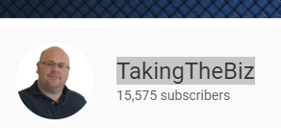  Really useful YouTube channel with wide range of revision videos on all business a level topics

Other recommended reads

Quality newspapers/magazines such as The Times, Guardian, Telegraph, Independent, journals such as The Economist (N.B there are reduced rates for students on some of these. Also, you can sign up online and receive free articles.

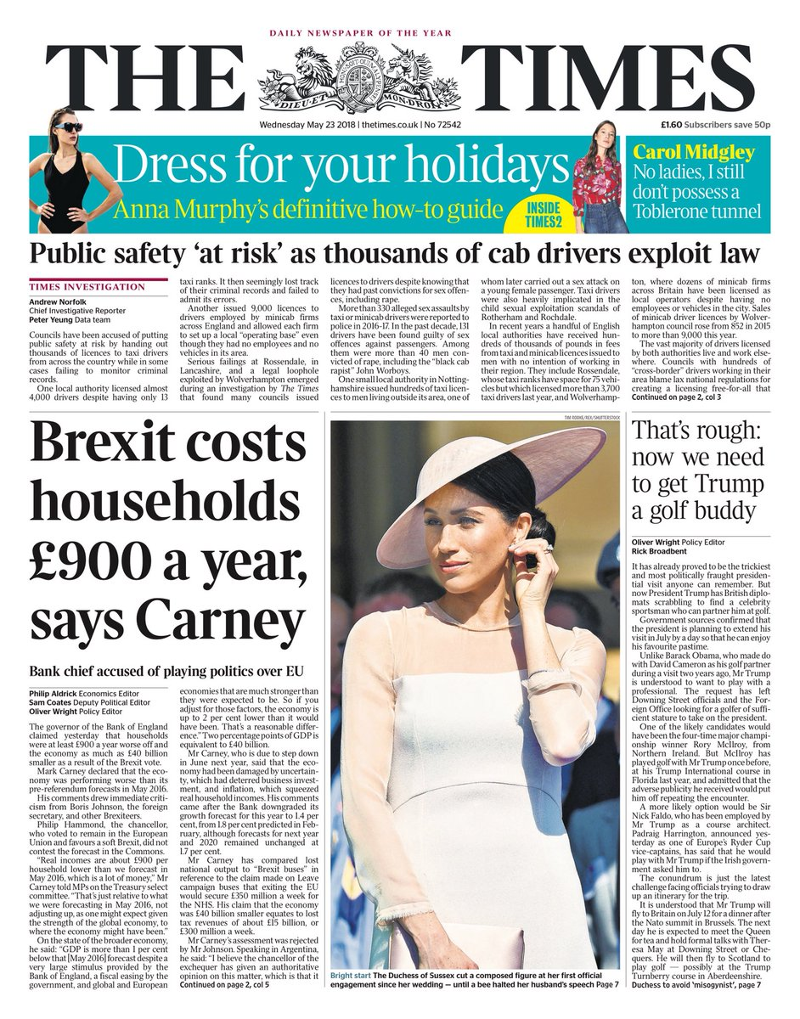  www.thetimes.co.uk | 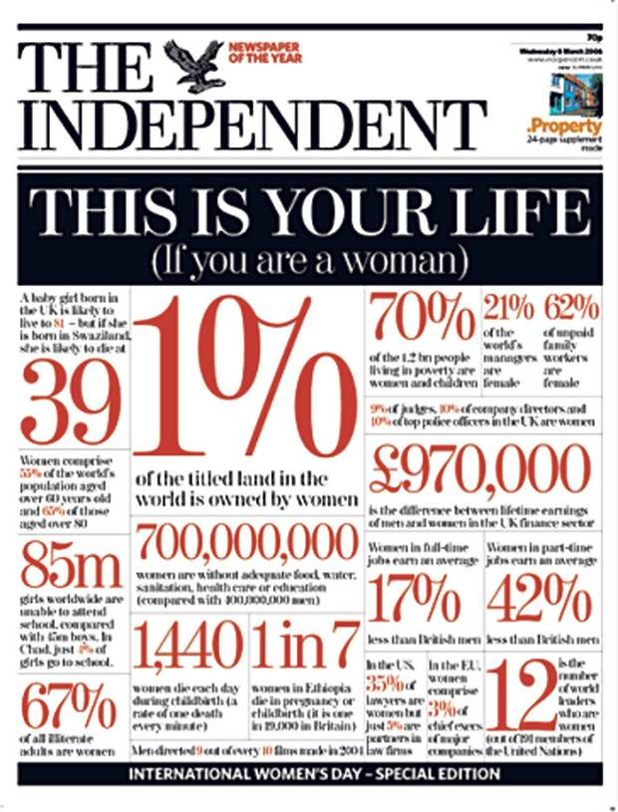  www.independent.co.uk | www.economist.com | 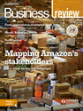  https://www.hoddereducation.co.uk/ magazines/ magazines-extras/business-review-extras
Other websites that are specific to BTEC Business

- Bee Business Be
  - http://www.beebusinessbee.co.uk/index.php
  - Also has You Tube Channel
- Two Teachers
  - https://www.youtube.com/channel/UCnVHZKYx1vWVnhRjJqJbNdQ
- Mrs Squires Means Business
  - https://www.youtube.com/channel/UCD_mCcetvZH3htOeNnewpqg
- BBC Bitesize
  - https://www.bbc.co.uk/bitesize/subjects/zpsvr82
- Sense Business Studies
  - https://www.youtube.com/playlist?list=PLEb-haXcornHwKinj_WBurLWyqDpn43Ne
  - Old specification but has lots of relevant and similar info to the new specification

Website and You Tube Playlists for other units

Unit 2 – Developing A Marketing Campaign

- You Tube
  - https://www.youtube.com/playlist?list=PLMg-z-Uc0ix0EjaRrlzx9TBIs7RrAtI_5

- BTEC – Guided Workbook
  - https://www.pearsonschoolsandfecolleges.co.uk/AssetsLibrary/SECTORS/FurtherEducationColleges/ReviseBTEC/samples/9781292150016-btec-bus-rw.pdf

- Info on each topic
  - https://www.learnmarketing.net/Unit2_Developing_a_marketing_campaign_overview.html

Unit 3 – Personal and Business Finance

- Bee Business Bee – You Tube Videos
  - https://www.youtube.com/playlist?list=PLBuW3SAj0djly2MaKyOzL4cnmeaPbEJj1
- Textbook
  - https://www.pearsonschoolsandfecolleges.co.uk/FEAndVocational/BusinessandEconomics/BTEC/BTECNationalsBusiness2016/Samples/Student-Book-1/unit-3.pdf
- Mr Harris – You Tube Videos
  - https://www.youtube.com/channel/UC1NwhtIucwbrG2wQ3xkX39Q/playlists?view=50&sort=dd&shelf_id=3

TV

The following television programmes are recommended for background business knowledge.

BBC News  Last news from around the world. | BBC Panorama  British current affairs documentary programme | BBC newnight  Key national and international news stories
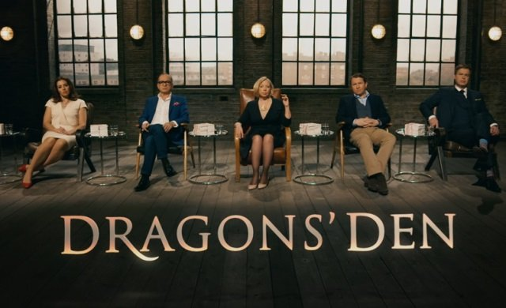  Dragons Den  Programme about entrepreneurs presenting their business ideas to gain funding from the Dragons. (Venture Capitalists) | The Apprentice  Programme about entrepreneurs working in teams and being interviewed so they can gain backing of Sir Alan Sugar for their business idea. | 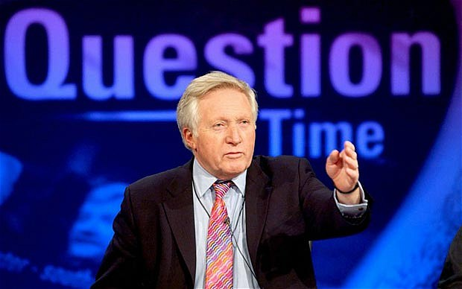  Question Time  Topical debate in which guests from the worlds of politics and the media answer questions posed by members of the public.
Undercover Boss  A CEO goes undercover to find out how a large firm is running. There are both UK and USA versions. Check catchup TV or YouTube | 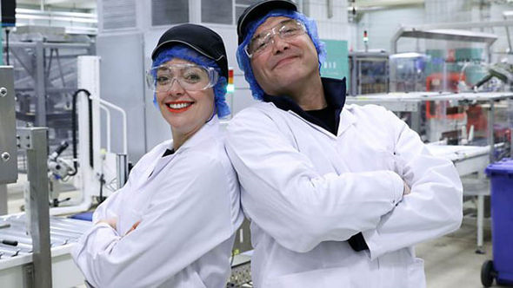  Inside the Factory  A fun insight into foods we eat and how they are made. Shows student the different production methods used. | Only Fools and Horses  Bit of comedy. The original sole trader “Del Boy”. Show goes through the trials and tribulations of Trotters Independent Traders!

