Transition Pack for A Level Chemistry

Get ready for A-level!
A guide to help you get ready for A-level Chemistry, including everything from topic guides to days out and online learning courses.
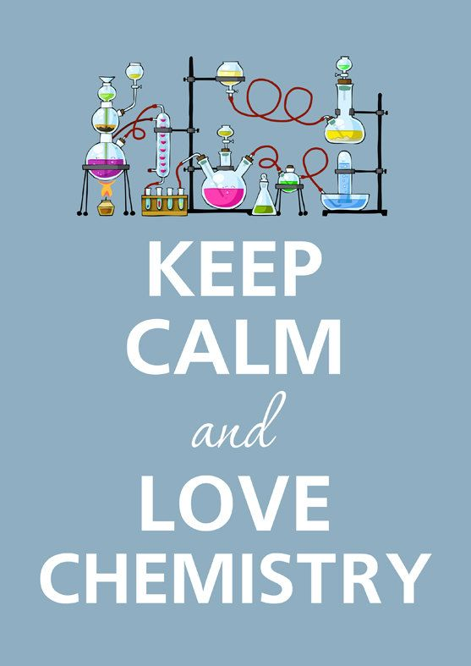
So you are considering A Level Chemistry?

This pack contains a programme of activities and resources to prepare you to start an A level in Chemistry in September. It is aimed to be used after you complete your GCSE, throughout the remainder of the summer term and over the Summer Holidays to ensure you are ready to start your course in September.

Book Recommendations
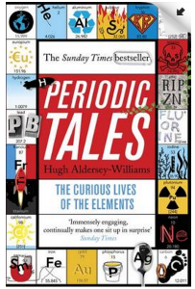
Periodic Tales: The Curious Lives of the Elements (Paperback) Hugh Aldersey-Williams
ISBN-10: 0141041455
http://bit.ly/pixlchembook1

This book covers the chemical elements, where they come from and how they are used. There are loads of fascinating insights into uses for chemicals you would have never even thought about.
The Science of Everyday Life: Why Teapots Dribble, Toast Burns and Light Bulbs Shine (Hardback) Marty Jopson
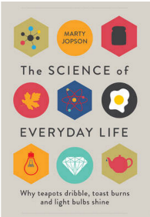
ISBN-10: 1782434186
http://bit.ly/pixlchembook2

The title says it all really, lots of interesting stuff about the things around you home!

Bad Science (Paperback) Ben Goldacre
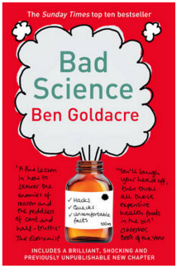
ISBN-10: 000728487X
http://bit.ly/pixlchembook3
Here Ben Goldacre takes apart anyone who published bad / misleading or dodgy science – this book will make you think about everything the advertising industry tries to sell you by making it sound ‘sciency’.

Calculations in AS/A Level Chemistry (Paperback) Jim Clark
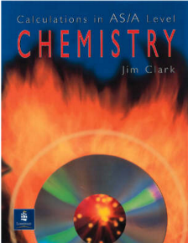
ISBN-10: 0582411270
http://bit.ly/pixlchembook4
If you struggle with the calculations side of chemistry, this is the book for you. Covers all the possible calculations you are ever likely to come across. Brought to you by the same guy who wrote the excellent chemguide.co.uk website.

Salters' Advanced Chemistry: Chemical Storylines
Do not feel you need to buy the latest edition (unless you are doing Salters chemistry!) You can pick up an old edition for a few pounds on ebay, gives you a real insight into how chemistry is used to solve everyday problems from global pollution through feeding to world to making new medicines to treat disease.
Videos to watch online
Rough science – the Open University – 34 episodes available
Real scientists are ‘stranded’ on an island and are given scientific problems to solve using only what they can find on the island.
Great fun if you like to see how science is used in solving problems.
There are six series in total
http://bit.ly/pixlchemvid1a
http://www.dailymotion.com/playlist/x2igjq_Rough-Science_rough-science-full-series/1#video=xxw6pr
or
http://bit.ly/pixlchemvid1b
https://www.youtube.com/watch?v=lUoDWAt259I
A thread of quicksilver – The Open University
A brilliant history of the most mysterious of elements – mercury. This program shows you how a single substance led to empires and war, as well as showing you come of the cooler properties of mercury.
http://bit.ly/pixlchemvid2
https://www.youtube.com/watch?v=t46lvTxHHTA
10 weird and wonderful chemical reactions
10 good demonstration reactions, can you work out the chemistry of …. any… of them?
http://bit.ly/pixlchemvid3
https://www.youtube.com/watch?v=0Bt6RPP2ANI
Chemistry in the Movies
Dantes Peak 1997: Volcano disaster movie.
Use the link to look at the Science of acids and how this links to the movie. http://www.open.edu/openlearn/science-maths-technology/science/chemistry/dantes-peak
http://www.flickclip.com/flicks/dantespeak1.html
http://www.flickclip.com/flicks/dantespeak5.html
Fantastic 4 2005 &2015: Superhero movie

Michio Kaku explains the “real” science behind fantastic four http://nerdist.com/michio-kaku-explains-the-real-science-behind-fantastic-four/

http://www.flickclip.com/flicks/fantastic4.html

Research activities
Use your online searching abilities to see if you can find out as much about the topic as you can. Remember it you are a prospective A level chemist, you should aim to push your knowledge.
You can make a 1-page summary for each one you research using Cornell notes:
http://coe.jmu.edu/learningtoolbox/cornellnotes.html
Task 1: The chemistry of fireworks
What are the component parts of fireworks? What chemical compounds cause fireworks to explode? What chemical compounds are responsible for the colour of fireworks?

Task 2: Why is copper sulfate blue?
Copper compounds like many of the transition metal compounds have got vivid and distinctive colours – but why?

Task 3: Aspirin
What was the history of the discovery of aspirin, how do we manufacture aspirin in a modern chemical process?

Task 4: The hole in the ozone layer
Why did we get a hole in the ozone layer? What chemicals were responsible for it? Why were we producing so many of these chemicals? What is the chemistry behind the ozone destruction?

Task 5: ITO and the future of touch screen devices
ITO – indium tin oxide is the main component of touch screen in phones and tablets. The element indium is a rare element and we are rapidly running out of it. Chemists are desperately trying to find a more readily available replacement for it. What advances have chemists made in finding a replacement for it?

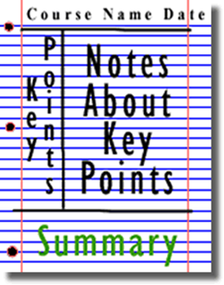

Figure 2: http://coe.jmu.edu/learningtoolbox/images/noteb4.gif
Recapping GCSE chemistry transition work
Instructions

You MUST complete all GCSE questions. This is to help you recap and retrieve vital knowledge you have learned during your GCSE course that provides the foundation for A-Level Chemistry to build upon.
Use your normal GCSE revision resources to help you complete them, but here are some suggestions:

www.senecalearning.com
www.bitesize.com
Youtube - Free Science Lessons
Youtube - Primrose Kitten

You MUST attempt the A-Level Questions. They are accessible to you with the GCSE content you have – you might just need to think outside the box a bit and stretch yourself! This gives insight into the style of questions at A-Level and shows the jump is not that large if you are fully prepped with all of your GCSE knowledge
CGP – ‘Head start to Chemistry’ and ‘Essential Maths Skills’ books
MaChemGuy – Prepare for A-Level Chemistry
ASFC Chemistry – Starting A-Level Chemistry

You MUST bring this to your first Chemistry Lesson in Year 12 and give it to your teacher

Atomic Structure

GCSE questions
Q1. This question is about the structure of the atom.
(a) Complete the sentences. Choose answers from the box. Each word may be used once, more than once, or not at all.
electron |  | ion |  | neutron
 | nucleus |  | proton
The centre of the atom is the _______________________ .
The two types of particle in the centre of the atom are the proton and the _______________________ .
James Chadwick proved the existence of the _______________________ .
Niels Bohr suggested particles orbit the centre of the atom. This type of particle is the ________________ .
The two types of particle with the same mass are the neutron and the _______________________ . (5)
The table below shows information about two isotopes of element X.

 | Mass number | Percentage (%) abundance
Isotope 1 | 63 | 70
Isotope 2 | 65 | 30
(b) Calculate the relative atomic mass (A_{r}) of element X using the equation:
Use the table above. Give your answer to 1 decimal place.
__________________________________________________________________________________________________________________________________________________A_{r} = _________________ (2)
(c) Suggest the identity of element X. Use the periodic table.

Element X is _________________________________________________________________________(1)
(d) The radius of an atom of element X is 1.2 × 10⁻¹⁰ m
The radius of the centre of the atom is 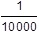 the radius of the atom.
Calculate the radius of the centre of an atom of element X. Give your answer in standard form.
_______________________________________________________________________________________________________________________________________________________________________________________________________________________________Radius = ___________________ m (2)
Q2. The diagram below represents different models of the atom.
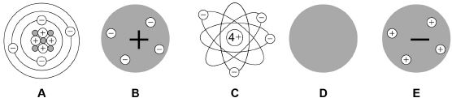
(a) Which diagram shows the plum pudding model of the atom? Tick one box.
(1)
(b) Which diagram shows the model of the atom developed from the alpha particle scattering experiment? Tick one box.
(1)
(c) Which diagram shows the model of the atom resulting from Bohr’s work? Tick one box.
(1)
(d) Define the mass number of an atom.
________________________________________________________________________________________________________________________________________________________________________(1)
(e) Element X has two isotopes. Their mass numbers are 69 and 71
The percentage abundance of each isotope is:
• 60% of ⁶⁹X
• 40% of ⁷¹X
Estimate the relative atomic mass of element X. Tick one box.
< 69.5
Between 69.5 and 70.0
Between 69.5 and 70.0
Between 70.0 and 70.5
> 70.5
(1)
A-Level question to give a go!
Q1. Which of these correctly shows the numbers of sub-atomic particles in a ⁴¹K⁺ ion?
 | Number of electrons | Number of protons | Number of neutrons
A | 19 | 19 | 20
B | 18 | 20 | 21
C | 18 | 19 | 22
D | 19 | 18 | 23
(Total 1 mark)
Q2. Magnesium exists as three isotopes: ²⁴Mg, ²⁵Mg and ²⁶Mg
(a) In terms of sub-atomic particles, state the difference between the three isotopes of magnesium.
____________________________________________________________________________________________________________________________________________________________________________(1)

(b) State how, if at all, the chemical properties of these isotopes differ.
Give a reason for your answer.
Chemical properties ______________________________________________________________________
Reason ____________________________________________________________________________________________________________________________________________________________________________(2)

Amount of Substance

GCSE questions
Q3. A student investigated the reactions of copper carbonate and copper oxide with dilute hydrochloric acid. In both reactions one of the products is copper chloride.
(a) A student wanted to make 11.0 g of copper chloride.
The equation for the reaction is:
CuCO₃ + 2HCl → CuCl₂ + H₂O + CO₂
Relative atomic masses, A_{r}: H = 1; C = 12; O = 16; Cl = 35.5; Cu = 63.5
Calculate the mass of copper carbonate the student should react with dilute hydrochloric acid to make 11.0 g of copper chloride.
___________________________________________________________________________________________________________________________________________________________________________________________________________Mass of copper carbonate = _________________________ g (4)
(b) The percentage yield of copper chloride was 79.1 %. Calculate the mass of copper chloride the student actually produced.

______________________________________________________________________________________________________________________Actual mass of copper chloride produced = ____________ g (2)

(c) Look at the equations for the two reactions:
Reaction 1 CuCO₃(s) + 2HCl(aq) → CuCl₂(aq) + H₂O(l) + CO₂(g)
Reaction 2 CuO(s) + 2HCl(aq) → CuCl₂(aq) + H₂O(l)
Reactive formula masses: CuO = 79.5; HCl = 36.5; CuCl₂ = 134.5; H₂O = 18
The percentage atom economy for a reaction is calculated using:
Calculate the percentage atom economy for Reaction 2.
______________________________________________________________________________________________________________________________________________________________________________________________________________Percentage atom economy = ________________________ % (3)

(d) The atom economy for Reaction 1 is 68.45 %. Compare the atom economies of the two reactions for making copper chloride. Give a reason for the difference.
__________________________________________________________________________________(1)

A-Level question to give a go!
Q3. Ethanol can be made from glucose by fermentation.
C₆H₁₂O₆ → 2C₂H₅OH + 2CO₂

In an experiment, 268 g of ethanol (M_{r} = 46.0) were made from 1.44 kg of glucose (M_{r} = 180.0).
What is the percentage yield?
A | 18.6%
B | 36.4%
C | 51.1%
D | 72.8%
(Total 1 mark)

Q4. A gas cylinder contains 5.0 kg of propane.
How many propane molecules are in the cylinder?
The Avogadro constant, L = 6.022 × 10²³ mol^{–1}
A | 6.8 × 10²²
B | 7.2 × 10²²
C | 6.8 × 10²⁵
D | 7.2 × 10²⁵

(Total 1 mark)

Bonding

GCSE questions
Q4. Figure 1 shows the structure of five substances.
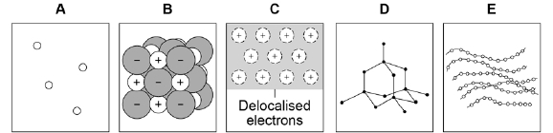
(a) Which diagram shows a gas? Tick (✔) one box.
A |  |  | B |  |  | C |  |  | D |  |  | E
(1)
(b) Which diagram shows the structure of diamond? Tick (✔) one box.
A |  |  | B |  |  | C |  |  | D |  |  | E
(1)
(c) Which diagram shows a metallic structure? Tick (✔) one box.
A |  |  | B |  |  | C |  |  | D |  |  | E
(1)
(d) Which diagram shows a polymer? Tick (✔) one box.
A |  |  | B |  |  | C |  |  | D |  |  | E
(1)

(e) A chlorine atom has 7 electrons in the outer shell.
Two chlorine atoms covalently bond to form a chlorine molecule, Cl₂

Figure 2 is a dot and cross diagram showing the outer shells and some electrons in a chlorine molecule.

Complete the dot and cross diagram. Show only the electrons in the outer shell.
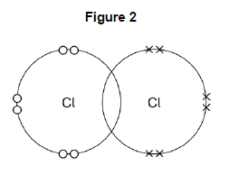
(1)
(f) What is the reason for chlorine’s low boiling point? Tick (✔) one box.
Strong covalent bonds
Strong forces between molecules
Weak covalent bonds
Weak forces between molecules
(1)
Figure 3 represents the structure of manganese oxide. Manganese oxide is an ionic compound.
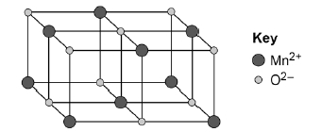
(g) Determine the empirical formula of manganese oxide. Use Figure 3.
_________________________________________________________________________________________________________________________________Empirical formula = ______________________ (1)

(h) Why does manganese oxide conduct electricity as a liquid? Tick (✔) one box.
Atoms move around in the liquid
Electrons move around in the liquid
Ions move around in the liquid
Molecules move around in the liquid
(1)
Q5. This question is about structure and bonding.

(a) Complete the dot and cross diagram to show the covalent bonding in a nitrogen molecule, N₂
Show only the electrons in the outer shell.
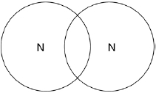
(2)
(b) Explain why nitrogen is a gas at room temperature. Answer in terms of nitrogen’s structure.
_________________________________________________________________________________________________________________________________________________________________________________________________________________________________________________________________________________________________________________________________________________(3)

(c) Graphite and fullerenes are forms of carbon. Graphite is soft and is a good conductor of electricity.
Explain why graphite has these properties. Answer in terms of structure and bonding.
________________________________________________________________________________________________________________________________________________________________________________________________________________________________________________________________________________________________________________________________________________________________________________________________________________________________________________(4)

A-Level question to give a go!
Q5. Which is the correct crystal structure for the substance named?
 | Substance | Structure
A | Iodine | Simple molecular
B | Diamond | Ionic
C | Sodium chloride | Giant covalent
D | Graphite | Metallic
(Total 1 mark)
Q6. What is the formula of calcium nitrate(V)?
A | CaNO₃
B | Ca(NO₃)₂
C | Ca₂NO₂
D | Ca(NO₂)₂
(Total 1 mark)
Q7. The table shows some data about the elements bromine and magnesium.

Element | Melting point / K | Boiling point / K
Bromine | 266 | 332
Magnesium | 923 | 1383
In terms of structure and bonding explain why the boiling point of bromine is different from that of magnesium. Suggest why magnesium is a liquid over a much greater temperature range compared to bromine.
____________________________________________________________________________________________________________________________________________________________________________________________________________________________________________________________________________________________________________________________________________________________________________________________________________________________________________________________________________________________________________________________________________________________________________________________________________________________________________________________________________________________________________________________________________________________________________________________________________________________________________________________________________________________________________________________________________________________________________________________(Total 5 marks)

Energetics
GCSE questions
Q6. Methane (CH₄) is used as a fuel.
(a) Methane burns in oxygen.
(i) The diagram below shows the energy level diagram for the complete combustion of methane.

Draw and label arrows on the diagram to show:
• the activation energy
• the enthalpy change, ΔH.
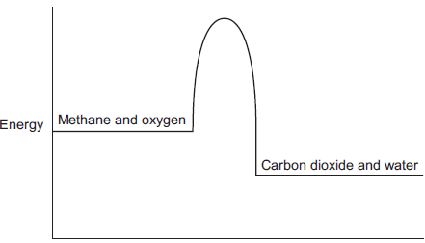
(2)
(ii) Complete and balance the symbol equation for the complete combustion of methane.
CH₄ + _____ CO₂ + _____ (2)

(ii) Explain why, in terms of the energy involved in bond breaking and bond making, the combustion of methane is exothermic.
_________________________________________________________________________________________________________________________________________________________________________________________________________________________________________________________________________________________________________________________________________________(3)
(b) Methane reacts with chlorine in the presence of sunlight. The equation for this reaction is:
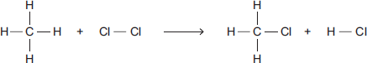
Some bond dissociation energies are given in the table.

Bond | Bond dissociation energy  in kJ per mole
C−H | 413
C−Cl | 327
Cl−Cl | 243
H−Cl | 432
(i) Show that the enthalpy change, ΔH, for this reaction is −103 kJ per mole.
_________________________________________________________________________________________________________________________________________________________________________________________________________________________________________________________________________________________________________________________________________________(3)

(ii) Methane also reacts with bromine in the presence of sunlight.
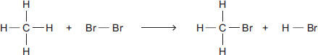
This reaction is less exothermic than the reaction between methane and chlorine.
The enthalpy change, ΔH, is −45 kJ per mole.
What is a possible reason for this? Tick () one box.
CH₃Br has a lower boiling point than CH₃Cl
The C−Br bond is weaker than the C−Cl bond.
The H−Cl bond is weaker than the H−Br bond.
Chlorine is more reactive than bromine.
(1)
A-Level question to give a go!
Q8. Calculate the enthalpy change, in kJ, for this dissociation of mole of propan-1-ol.
C₃H₇OH(g) ⟶ 3C(g) + 8H(g) + O(g)

Mean bond dissociation enthalpy / kJ mol⁻¹ |  |  |  | 412 | 348 | 360 | 463
A | −4751
B | −4403
C | +4403
D | +4751
(Total 1 mark)

Q9. Hydrogen is produced by the reaction of methane with steam. The reaction mixture reaches a state of dynamic equilibrium.
CH₄(g) + H₂O(g) ⇌ CO(g) + 3H₂(g) ∆H = +206 kJ mol⁻¹
Some enthalpy data is given in the table.

Bond | C–H | O–H | H–H | C≡H
Bond enthalpy /  kJ mol⁻¹ | 413 | 463 | 436 | To be calculated
Use the information in the table and the stated enthalpy change to calculate the missing bond enthalpy.
A | 234
B | 1064
C | 1476
D | 1936
(Total 1 mark)

Kinetics

GCSE questions
Q7. When sodium thiosulfate solution reacts with dilute hydrochloric acid, the solution becomes cloudy.
The equation for the reaction is:
Na₂S₂O₃(aq) + 2 HCl(aq) ⟶ 2 NaCl(aq) + SO₂(g) + H₂O(l) + S(s)
Some students used this reaction to investigate the effect of concentration on rate of reaction. The table shows the students’ results.
Concentration of sodium thiosulfate solution in mol / dm³ | Time for cross to become no longer visible in s
0.020 | 170
0.040 | 90
0.060 | 82
0.080 | 42
0.100 | 34
0.120 | 30
0.140 | 28

(a) Plot the data from the table above on the graph below. Draw a line of best fit.
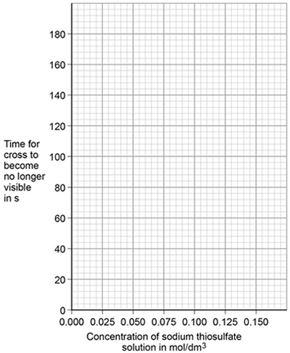
(3)
The students repeated the investigation two more times. They obtained similar results each time.

(b) The students analysed their results to give a conclusion and an explanation for their investigation.

Conclusion: ‘The higher the concentration, the lower the rate of reaction.’

Explanation: ‘At higher concentrations, the particles have more energy, so they are moving faster. Therefore the collisions are more energetic.’

The students are not correct.
Give a correct conclusion and explanation for the results of the investigation.

Conclusion _________________________________________________________________________________________________________________________________________________

Explanation ____________________________________________________________________________________________________________________________________________________________________________________________________________________________________________________________________________________________________________________________________________(3)

(c) A solution containing 0.18 g of sodium thiosulfate reacts with dilute hydrochloric acid in 2 minutes.
Calculate the mean rate of reaction in g / s. Give your answer in standard form.
_______________________________________________________________________________________________________________________________________________________________________________________________________________________Mean rate of reaction = ____________________ g / s (3)

A-Level question to give a go!
Q10. Line X in the diagram represents the volume (V) of gas formed with time (t) in a reaction between an excess of magnesium and aqueous sulfuric acid.
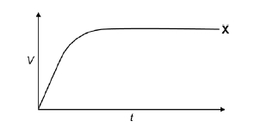
Which line represents the volume of hydrogen formed, at the same temperature and pressure, when the concentration of sulfuric acid has been halved?
A | 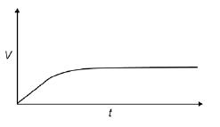
B | 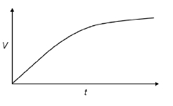
C | 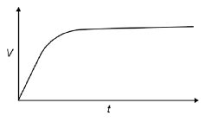
D | 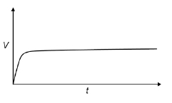
(Total 1 mark)
Q11. The gas-phase reaction between hydrogen and chlorine is very slow at room temperature.
H₂(g) + Cl₂(g) → 2HCl(g)
(a) Define the term activation energy.
______________________________________________________________________________________________________________________________________________________________________________(2)
(b) Give one reason why the reaction between hydrogen and chlorine is very slow at room temperature.
______________________________________________________________________________________________________________________________________________________________________________(1)
(c) Explain why an increase in pressure, at constant temperature, increases the rate of reaction between hydrogen and chlorine.
______________________________________________________________________________________________________________________________________________________________________________(2)
(d) Explain why a small increase in temperature can lead to a large increase in the rate of reaction between hydrogen and chlorine.
______________________________________________________________________________________________________________________________________________________________________________(2)
(e) Give the meaning of the term catalyst.
______________________________________________________________________________________________________________________________________________________________________________(1)
(f) Suggest one reason why a solid catalyst for a gas-phase reaction is often in the form of a powder.
______________________________________________________________________________________(1)

Chemical Equilibria, Le Chatelier’s Principle and K_{c}

GCSE questions
Q8. In industry ethanol is produced by the reaction of ethene and steam at 300°C and 60 atmospheres pressure using a catalyst.
The equation for the reaction is: C₂H₄ (g) + H₂O (g) C₂H₅OH (g)
(a) The forward reaction is exothermic.
Use Le Chatelier’s Principle to predict the effect of increasing temperature on the amount of ethanol produced at equilibrium. Give a reason for your prediction.
______________________________________________________________________________________________________________________________________________________________________________(2)
(b) Explain how increasing the pressure of the reactants will affect the amount of ethanol produced at equilibrium.
______________________________________________________________________________________________________________________________________________________________________________(2)

A-Level question to give a go!

Q12. Which statement is not correct about the industrial preparation of ethanol by the hydration of ethene at 300 °C?
C₂H₄(g) + H₂O(g) ⇌ C₂H₅OH(g) ∆H = –46 kJ mol^{–1}

A | The reaction is catalysed by an acid.
B | The higher the pressure, the higher the equilibrium yield of ethanol.
C | The higher the temperature, the higher the equilibrium yield of ethanol.
D | A low equilibrium yield of ethanol is acceptable because unreacted ethene is recycled.
(Total 1 mark)
Q13. The forward reaction in this equilibrium is endothermic
COCl₂ (g) ⇌ CO(g) + Cl₂ (g)
Which statement is correct?

A | If the total pressure is increased at constant temperature, the proportion of COCl₂ in the equilibrium mixture will decrease
B | Use of a catalyst will increase the proportion of COCl₂ in the equilibrium mixture at constant temperature and pressure
C | Reducing the equilibrium concentration of CO will increase the value of the equilibrium constant
D | Raising the temperature from 373 K to 473 K will increase the value of the equilibrium constant
(Total 1 mark)

Oxidation, Reduction and Redox equations

GCSE questions
Q9. This question is about halogens and their compounds.
(a) What is the ionic equation for the reaction of chlorine with potassium iodide? Tick one box.
Cl₂ + 2K → 2KCl
2I⁻ + Cl₂ → I₂ + 2Cl⁻
I⁻ + Cl → I + Cl⁻
I⁻ + K⁺ → KI
(1)

Q10. Titanium is a transition metal.
Titanium is extracted from titanium dioxide in a two-stage industrial process.
Stage 1 TiO₂ + 2 C + 2 Cl₂ ⟶ TiCl₄ + 2 CO
Stage 2 TiCl₄ + 4 Na ⟶ Ti + 4 NaCl
In Stage 2, sodium displaces titanium from titanium chloride.
(a) Sodium atoms are oxidised to sodium ions in this reaction. Why is this an oxidation reaction?
_______________________________________________________________________(1)
(b) Complete the half equation for the oxidation reaction.
Na ⟶ ____________ + ____________ (1)

A-Level question to give a go!
Q14. In which reaction is the metal oxidised?
A | 2Cu²⁺ + 4I– 2CuI + I₂
B | [Fe(H₂O)₆]³⁺ + Cl– [Fe(H₂O)₅(Cl)]²⁺ + H₂O
C | [CoCl₄]^{2–} + 6H₂O [Co(H₂O)₆]²⁺ + 4Cl–
D | Mg + S MgS
(Total 1 mark)

Periodicity

GCSE questions
Q11. This question is about metals.
(a) Which unreactive metal is found in the Earth as the metal itself? Tick () one box
aluminium
gold
magnesium
(1)
(b) Complete the sentence.
Aluminium is an element because aluminium is made of only one type of _________________________ .
(1)
(c) Figure 1 shows the electronic structure of an aluminium atom.
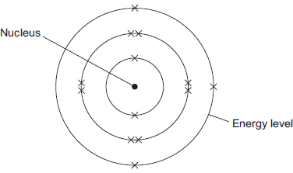
(i) Use the correct words from the box to complete the sentence.

electrons | ions | protons | neutrons | shells
The nucleus of an aluminium atom contains _______________ and _______________ . (2)
(ii) Complete the sentence.
In the periodic table, aluminium is in Group ___________________ (1)

(d) Aluminium is used for kitchen foil. Figure 2 shows a symbol on a box of kitchen foil.
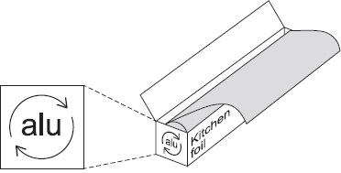
The symbol means that aluminium can be recycled. It does not show the correct chemical symbol for aluminium.
(i) What is the correct chemical symbol for aluminium? ___________________________ . (1)
(ii) Give two reasons why aluminium should be recycled.
______________________________________________________________________________________________________________________________________________________________________________(2)

(e) Aluminium has a low density, conducts electricity and is resistant to corrosion.
Which one of these properties makes aluminium suitable to use as kitchen foil? Give a reason for your answer.
________________________________________________________________________________________________________________________________________________________________________________________________________________________________________________________________(2)

A-Level question to give a go!
Q15. Which of the following is a correct statement about the trend in atomic radius across Period 3 of the Periodic Table?
A | radius increases because the atoms have more electrons
B | radius decreases because nuclear charge increases
C | radius increases because shielding (screening) increases
D | radius decreases because shielding (screening) decreases
(Total 1 mark)

Group 2 – The Alkaline Earth Metals

GCSE questions
Q12. This question is about compounds.
(a) The table gives information about the solubility of some compounds.
Soluble compounds
All potassium and sodium salts
All nitrates
Chlorides, bromides and iodides, except those of silver and lead

Use information from the table to answer these questions.
(i) Name a soluble compound that contains silver ions.
______________________________________________________________________________________(1)
(ii) Name a soluble compound that contains carbonate ions.
______________________________________________________________________________________(1)
(b) Metal oxides react with acids to make salts. What type of compound is a metal oxide?
______________________________________________________________________________________(1)
(c) Lead nitrate solution is produced by reacting lead oxide with nitric acid.
(i) State how solid lead nitrate can be obtained from lead nitrate solution.
________________________________________________________________________________________________________________________________________________________________________________(1)
(ii) Balance the equation for the reaction.
PbO + HNO₃ Pb(NO₃)₂ + H₂O
(1)
(iii) Give the total number of atoms in the formula Pb(NO₃)₂
_____________________________________________________________________________________(1)

A-Level question to give a go!
Q16. (a) Nickel is a metal with a high melting point.
(i) Explain, in terms of its structure and bonding, why nickel has a high melting point.
__________________________________________________________________________________________________________________________________________________________________________________________________________________________________________________________________________________________________________________________________________________________(2)

(ii) Draw a labelled diagram to show the arrangement of particles in a crystal of nickel.
In your answer, include at least six particles of each type.

(2)
(iii) Explain why nickel is ductile (can be stretched into wires).
____________________________________________________________________________________________________________________________________________________________________________(1)

Group 7 – The Halogens

GCSE questions
Q13. The halogens are elements in Group 7.
(a) Bromine is in Group 7.
Give the number of electrons in the outer shell of a bromine atom. _______________________________(1)

(b) Bromine reacts with hydrogen. The gas hydrogen bromide is produced.
What is the structure of hydrogen bromide? Tick one box.
Giant covalent
Ionic lattice
Metallic structure
Small molecule
(1)

(c) What is the formula for fluorine gas? Tick one box.
F
F₂
F²
2F
(1)
A student mixes solutions of halogens with solutions of their salts.
The table below shows the student’s observations.
 |  | Potassium chloride (colourless) | Potassium bromide (colourless) | Potassium iodide (colourless)
Chlorine (colourless) |  |  | Solution turns orange | Solution turns brown
Bromine (orange) |  | No change |  | Solution turns brown
Iodine (brown) |  | No change | No change
(d) Explain how the reactivity of the halogens changes going down Group 7. Use the results in the table above.
______________________________________________________________________________________________________________________________________________________________________________________________________________________________________________________________________________________________________________________________________________________(3)

A-Level question to give a go!
Q17. An aqueous solution of a white solid gives a yellow precipitate with aqueous silver nitrate. The formula of the white solid could be
A AgBr
B AgI
C NaBr
D NaI
(Total 1 mark)

Q18. What will you see when a solution of silver nitrate is added to a solution containing bromide ions, and concentrated aqueous ammonia is added to the resulting mixture?
A a white precipitate soluble in concentrated aqueous ammonia
B a white precipitate insoluble in concentrated aqueous ammonia
C a cream precipitate soluble in concentrated aqueous ammonia
D a yellow precipitate insoluble in concentrated aqueous ammonia
(Total 1 mark)
Introduction to Organic Chemistry

GCSE questions
Q14. Scientists found that a compound contained:
22.8% sodium; 21.8% boron; and 55.4% oxygen.
Use the percentages to calculate the empirical formula of the compound.
Relative atomic masses (A _{r}): B = 11; O = 16; Na = 23
To gain full marks you must show all your working.
________________________________________________________________________________________________________________________________________________________________________________________________________________________________________________________________________________________________________________________________________________________________________________________________________________________________________________________________________________________________________________________________________________________________________________________________________________________________________________________________________________________________________________________________________________________________________________________________________________________________Empirical formula = ________________________________(Total 5 marks)

A-Level question to give a go!
Q19. An organic compound is found to contain 40.0% carbon, 6.7% hydrogen and 53.3% oxygen.
Which of the following compounds could this be?
A | Ethanol
B | Ethanoic acid
C | Methanol
D | Methanoic acid
(Total 1 mark)

Alkanes

GCSE questions
Q15. This question is about hydrocarbons.
The table gives information about four hydrocarbons. The hydrocarbons are four successive members of a homologous series.

Hydrocarbon | Formula | Boiling point in °C
A | C₄H₁₀ | 0
B |  | 36
C | C₆H₁₄ | 69
D | C₇H₁₆ | 98
(a) What is the formula of hydrocarbon B? Tick (✔) one box.
C₄H₁₂
C₅H₁₂
C₅H₁₂
C₆H₁₂
(1)

(b) What is the simplest ratio of carbon : hydrogen atoms in a molecule of hydrocarbon A?
Ratio = 2 : _______ (1)
(c) Which hydrocarbon is a gas at room temperature (25 °C)? Tick (✔) one box.
A |  |  | B |  |  | C |  |  | D
(1)
(d) Which hydrocarbon is most flammable? Tick (✔) one box.
A |  |  | B |  |  | C |  |  | D
(1)
(e) Which two substances are produced when a hydrocarbon completely combusts in air? Tick (✔) two boxes.
Carbon
Carbon dioxide
Hydrogen
Sulfur dioxide
Water
(2)
The diagram shows the displayed structure of a hydrocarbon molecule.
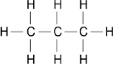
(f) What is the name of the hydrocarbon in the diagram above? Tick (✔) one box.

Butane
Ethane
Methane
Propane
(1)

Q16. This question is about hydrocarbons.
(a) The names and formulae of three hydrocarbons in the same homologous series are:
Ethane C₂H₆
Propane C₃H₈
Butane C₄H₁₀
The next member in the series is pentane. What is the formula of pentane?
_________________________________________________________________________________(1)
(b) Which homologous series contains ethane, propane and butane? Tick one box.
Alcohols
Alkanes
Alkenes
Carboxylic acids
(1)
(c) Propane (C₃H₈) is used as a fuel. Complete the equation for the complete combustion of propane.
C₃H₈ + 5O₂ → 3 _______________ + 4 _________________
(2)
(d) Octane (C₈H₁₈) is a hydrocarbon found in petrol. Explain why octane is a hydrocarbon.
___________________________________________________________________________________________________________________________________________________________________________(2)

(e) The table below gives information about the pollutants produced by cars using diesel or petrol as a fuel.

Fuel | Relative amounts of pollutants
 | Oxides of Nitrogen | Particulate matter | Carbon dioxide
Diesel | 31 | 100 | 85
Petrol | 23 | 0 | 100
Compare the pollutants from cars using diesel with those from cars using petrol.
__________________________________________________________________________________________________________________________________________________________________________________________________________________________________________________________________________________________________________________________________________________________________________(3)
(f) Pollutants cause environmental impacts. Draw one line from each pollutant to the environmental impact caused by the pollutant.
Pollutant |  |  |  |  |  | Environmental impact caused by the pollutant
 |  |  |  |  |  |  | Acid rain
 | Oxides of nitrogen |  |  |  |  |  | Flooding
 |  |  |  |  |  |  | Global dimming
 | Particulate matter |  |  |  |  |  | Global warming
 |  |  |  |  |  |  | Photosynthesis
(2)
A-Level question to give a go!
Q20. Which correctly represents an incomplete combustion of pentane?
A | C₅H₁₂ + 8O₂ ⟶ 5CO₂ + 6H₂O
B | C₅H₁₂ + 8O₂ ⟶ 4CO + CO₂ + 6H₂O
C | C₅H₁₂ + 6O₂ ⟶ 4CO + CO₂ + 6H₂O
D | C₅H₁₂ + 5O₂ ⟶ 4CO + CO₂ + 4H₂O + 2H₂
(Total 1 mark)
Q21. Tetradecane (C₁₄H₃₀) is an alkane found in crude oil. When tetradecane is heated to a high temperature, one molecule of tetradecane decomposes to form one molecule of hexane and three more molecules.

Which of the following could represent this reaction?
A | C₁₄H₃₀ → C₆H₁₄ + C₄H₈ + 2C₂H₄
B | C₁₄H₃₀ → C₆H₁₄ + C₆H₁₂ + C₂H₄
C | C₁₄H₃₀ → C₅H₁₂ + 3C₃H₆
D | C₁₄H₃₀ → C₆H₁₄ + C₂H₆ + 2C₃H₆
(Total 1 mark)

Q22. Petrol contains saturated hydrocarbons. Some of the molecules in petrol have the molecular formula C₈H₁₈ and are referred to as octanes. These octanes can be obtained from crude oil by fractional distillation and by cracking suitable heavier fractions.

Petrol burns completely in a plentiful supply of air but can undergo incomplete combustion in a car engine.

(a) State the meaning of both the words saturated and hydrocarbon as applied to the term saturated hydrocarbon. Name the homologous series to which C₈H₁₈ belongs.

________________________________________________________________________________________________________________________________________________________________________________________________________________________________________________________________________________________________________________________________________________________________________________________________________________________________________________(3)
(b) Outline the essential features of the fractional distillation of crude oil that enable the crude oil to be separated into fractions.
________________________________________________________________________________________________________________________________________________________________________________________________________________________________________________________________________________________________________________________________________________________________________________________________________________________________________________________________________________________________________________________________________(4)

Halogenalkanes

GCSE questions
Q17. During the test for unsaturation – a haloalkane is made. Describe the test for unsaturation
Test _________________________________________________________________________
Result _______________________________________________________________________(2)

Alkenes

GCSE questions
Q18. This question is about organic compounds. Hydrocarbons can be cracked to produce smaller molecules.
The equation shows the reaction for a hydrocarbon, C₁₈H₃₈
C₁₈H₃₈ → C₆H₁₄ + C₄H₈ + 2 C₃H₆ + C₂H₄
(a) Which product of the reaction shown is an alkane? Tick one box.
C₂H₄
C₃H₆
C₄H₈
C₆H₁₄
(1)

(b) The table below shows the boiling point, flammability and viscosity of C₁₈H₃₈ compared with the other hydrocarbons shown in the equation.

 | Boiling point | Flammability | Viscosity
A | highest | lowest | highest
B | highest | lowest | lowest
C | lowest | highest | highest
D | lowest | highest | lowest
Which letter, A, B, C or D, shows how the properties of C₁₈H₃₈ compare with the properties of C₂H₄, C₃H₆, C₄H₈ and C₆H₁₄? Tick one box.
A
B
C
D
(1)

(c) The hydrocarbon C₄H₈ was burnt in air. Incomplete combustion occurred.
Which equation, A, B, C or D, correctly represents the incomplete combustion reaction?
A C₄H₈ + 4O → 4CO + 4H₂
B C₄H₈ + 4O₂ → 4CO + 4H₂O
C C₄H₈ + 6O₂ → 4CO₂ + 4H₂O
D C₄H₈ + 8O → 4CO₂ + 4H₂

Tick one box.
A
B
C
D
(1)
(d) Propanoic acid is a carboxylic acid. Which structure, A, B, C or D, shows propanoic acid?
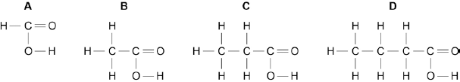
Tick one box.
A
B
C
D
(1)
(e) Propanoic acid is formed by the oxidation of which organic compound? Tick one box.
Propane
Propene
Propanol
Polyester
(1)

Q19. A molecule of ethene (C₂H₄) is represented as:
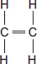
(a) A sample of ethene is shaken with bromine water. Complete the sentence.
The bromine water turns from orange to _____________________________________________________(1)

(b) Most ethene is produced by the process of cracking.
(i) Decane (C₁₀H₂₂) can be cracked to produce ethene (C₂H₄) and one other product.
Complete the equation to show the formula of the other product.
C₁₀H₂₂ C₂H₄ + _____________ (1)

(c) Many molecules of ethene join together to produce poly(ethene).
(i) Complete the structure of the polymer in the equation.
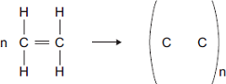
(2)
(ii) Some carrier bags are made from poly(ethene). Some carrier bags are made from cornstarch.
Suggest two benefits of using cornstarch instead of poly(ethene) to make carrier bags.

___________________________________________________________________________________________________________________________________________________________________________________________________________________________________________________________________(2)

A-Level question to give a go!
Q23. Consider the following reactions.
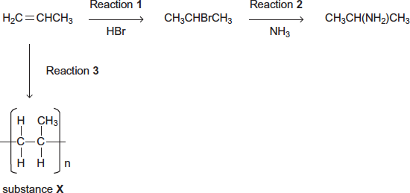
(a) State the type of reaction in Reaction 3. Give the name of substance X.
_______________________________________________________________________________________________________________________________________________ (2)

Alcohols

GCSE questions
Q20. The diagrams represent two compounds, A and B.
Compound A Compound B
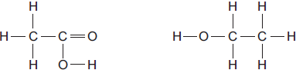
(a) (i) Compound B is an alcohol. Name compound B.
_______________________________________________________________________ (1)
(ii) Use the correct answer from the box to complete the sentence.
burned | decomposed | oxidised
To form compound A, compound B is ____________________________________________________(1)

(iii) Compounds A and B are both colourless liquids.
A test tube contains a colourless liquid, which could be either compound A or compound B. Describe a simple chemical test to show which compound, A or B, is in the test tube.
______________________________________________________________________________________________________________________________________________________________________________________________________________________________________________________________________________________________________________________________________________________(2)
A-Level question to give a go!
Q24. A group of students wanted to produce a biofuel to power the central heating system in their school. They collected scraps of fruits and vegetables from the kitchens and fermented them with yeast, in the absence of air, in order to produce ethanol.
The aqueous mixture was filtered to remove the remaining solids.
The students then set up the apparatus shown in the diagram below and placed the aqueous mixture in the round bottomed flask.
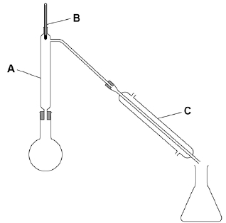
(a) Describe how the students would use this apparatus to collect a sample of ethanol. Include in your answer the functions of the parts of the apparatus labelled A, B and C.
________________________________________________________________________________________________________________________________________________________________________________________________________________________________________________________________________________________________________________________________________________________________________________________________________________________________________________________________________________________________________________________________________________________________________________________________________________________________________________________________________________________________________________________________________________________ (6)

Organic Analysis

GCSE questions
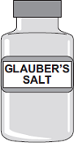
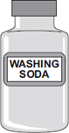
Q21. Four bottles of chemicals made in the 1880s were found recently in a cupboard during a Health and Safety inspection at Lovell Laboratories.
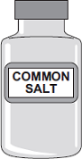
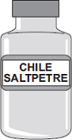

Sodium carbonate sodium chloride sodium nitrate sodium sulfate

The chemical names are shown below each bottle.

(a) You are provided with the following reagents:
• aluminium powder
• barium chloride solution acidified with dilute hydrochloric acid
• dilute hydrochloric acid
• silver nitrate solution acidified with dilute nitric acid
• sodium hydroxide solution.
• limewater
• red litmus paper
(i) Describe tests that you could use to show that these chemicals are correctly named.
In each case give the reagent(s) you would use and state the result.
Test and result for carbonate ions:
____________________________________________________________________________________________________________________________________________________________________________
Test and result for chloride ions:
____________________________________________________________________________________________________________________________________________________________________________

Test and result for nitrate ions:
____________________________________________________________________________________________________________________________________________________________________________
Test and result for sulfate ions:
__________________________________________________________________________________________________________________________________________________________________________(4)
(ii) Suggest why a flame test would not distinguish between these four chemicals.
___________________________________________________________________________________(1)
(b) Instrumental methods of analysis linked to computers can be used to identify chemicals. Give two advantages of using instrumental methods of analysis.
________________________________________________________________________________________________________________________________________________________________________________________________________________________________________________________________(2)

GCSE to A-Level Chemistry – Skills Transition
Balancing Equations

Use this method to help you https://www.youtube.com/watch?v=ab0gYBdHU-k
GCSE questions
Q1. (a) Balance these chemical equations.
(i) H₂ + O₂ → H₂O (1)
(ii) Al + O₂ → Al₂O₃ (1)
(b) Briefly explain why an unbalanced chemical equation cannot fully describe a reaction.
_____________________________________________________________________________________________________________________________________________________________________________________________________________________________________________________________(2
Q2. The following passage was taken from a chemistry textbook.
Germanium is a white, shiny, brittle element. It is used in the electronics industry because it is able to conduct a small amount of electricity.

It is made from germanium oxide obtained from flue dusts of zinc and lead smelters.
The impure germanium oxide from the flue dusts is changed into germanium by the process outlined below.

STEP 1 The germanium oxide is reacted with hydrochloric acid to make germanium tetrachloride. This is a volatile liquid in which the germanium and chlorine atoms are joined by covalent bonds.
STEP 2 The germanium tetrachloride is distilled off from the mixture.
STEP 3 The germanium tetrachloride is added to an excess of water to produce germanium oxide and hydrochloric acid.
STEPS 1 to 3 are repeated several times.
STEP 4 The pure germanium oxide is reduced by hydrogen to form germanium.

(a) Balance the equation below which represents the reaction in step 1.
GeO₂ + ______ HCl → GeCl₄ + ______ H₂O (1)
(b) Write a word equation for the reaction in step 3.
______________________________________________________________________ (1)

Q3. (a) Cola drinks contain phosphoric acid, H3PO4. The two equations show how phosphoric acid can be made from phosphorus.

Balance these two equations.
(i) P₄ + ____ O₂ → P₄O₁₀ (1)
(ii) P₄O₁₀ + ________ H₂O → 4H₃PO₄ (1)

Some more practice
4) Mg + O2 → MgO

5) H2 + O2 → H2O

6) Fe + HCl → FeCl2 + H2

7) CuO + HNO3→ Cu(NO3)2 + H2O

8) Ca(OH)2 + HCl → CaCl2 + H2O

9) KHCO3 + H2SO4 → K2SO4 + CO2 + H2O

10) Al + Cl2 → AlCl3

Even more practice - Balancing Equations Game

A-Level question to give a go!
Q11. Copper can be produced from rock that contains CuFeS₂
(a) Balance the equations for the two stages in this process.
.....CuFeS₂ + .....O₂ + .....SiO₂ ⟶ .....Cu₂S + .....Cu₂O + .....SO₂ + .....FeSiO₃
.....Cu₂S + .....Cu₂O ⟶ .....Cu + .....SO₂
(2)

Formula Literacy

For each of the following compounds;
- Identify the number of atoms of each element
- The formula of the ions it consists of
- Name it
- Challenge yourself: calculate its RFM
e.g. the first one is done for you:
1. NaNO₃
1 x sodium atom, 1 x nitrogen atom, 3 x oxygen atoms
Na+ and NO₃-
Sodium nitrate
Challenge: (1 x 23) + (1 x 14) + (3 x 16) = 85

2. Na₂O

3. K₃PO₄

4. CaBr₂

5. Al₂O₃

6. NH₄OH

7. (NH₄)₂SO₄

SI units

To reduce confusion and to help with conversion between different units, there is a standard system of units called the SI units which are used for most scientific purposes.

These units have all been defined by experiment so that the size of, say, a metre in the UK is the same as a metre in China. The seven SI base units are:

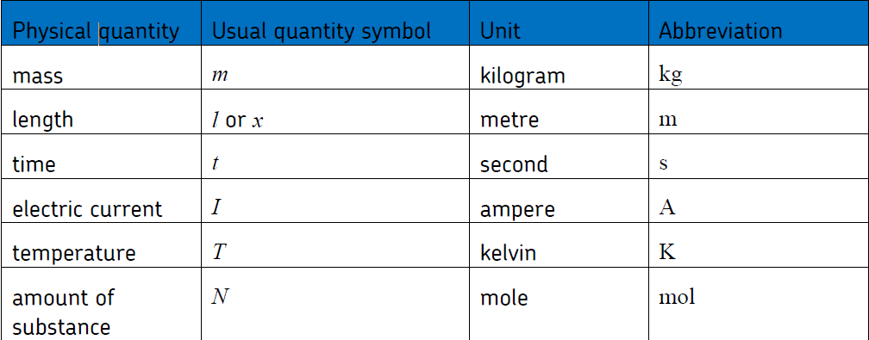

All other units can be derived from the SI base units.

For example, area is measured in square metres (written as m²) and speed is measured in metres per second (written as ms^{–1}).

It is not always appropriate to use a full unit. For example, measuring the width of a hair or the distance from Manchester to London in metres would cause the numbers to be difficult to work with.

Prefixes are used to multiply each of the units. You will be familiar with centi (meaning 1/100), kilo (1000) and milli (1/1000) from centimetres, kilometres and millimetres.

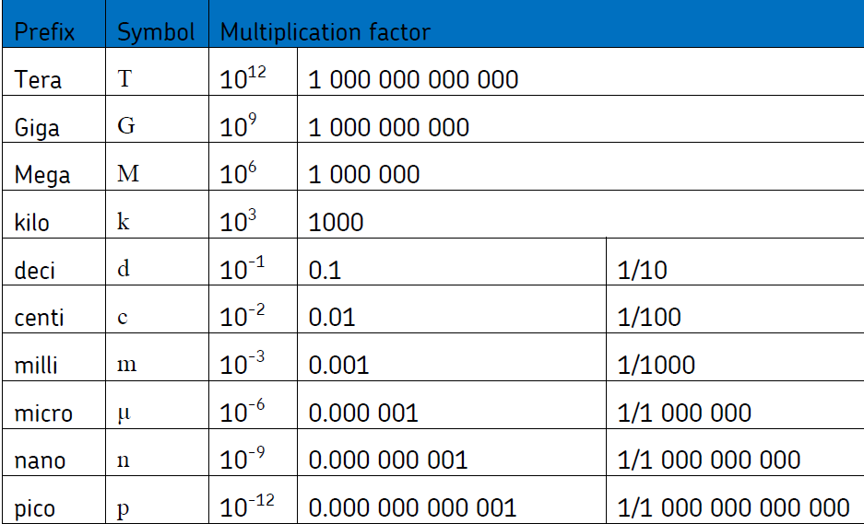
There is a wide range of prefixes. The majority of quantities in scientific contexts will be quoted using the prefixes that are multiples of 1000. For example, a distance of 33 000 m would be quoted as 33 km.

For the following quantities, which SI unit and most appropriate prefix would you use?

1. The mass of water in a test tube.

2. The time taken for a solution to change colour.

3. The radius of a gold atom.

4. The volume of water in a burette.

5. The amount of substance in a beaker of sugar.

6. The temperature of the blue flame from a Bunsen burner.

Rewrite the following quantities.
7. 0.00122 metres in millimetres

8. 104 micrograms in grams

9. 1.1202 kilometres in metres

10. 70 decilitres in millilitres

11. 70 decilitres in litres

12. 10 cm³ in litres

Good luck and see you in September!

