Battleships
- Create a new Python file.
- Type in the program on the back of this sheet.
- Play the game and see how it works!

Tasks
- When the game starts, ask the user for their name. This name should then be used to personalise the messages that are displayed.
- Change the game so that it plays on a grid of 9×9 squares, and allows the player to have 30 torpedoes to find the enemy ship.
- Modify the program so that the player cannot fire a torpedo at a location they have already missed. Display an appropriate error message, and the player should not lose one of their torpedoes in this case. (Tricky)
- If the player wins the game, display how many torpedoes it took to sink the ship. (Not too hard!)
- Modify the game so that there are two hidden ships. Both ships need to be found before the game is won. (A little bit tougher)
- Now make it so there are ten hidden ships to be found. The program should display how many are still to be found after each go. (Really easy if you did the previous task well…)

Modify the Battleship program so that there are only two hidden ships, but the first ship is length 3 and horizontal and the second ship is length 5 and vertical. All positions that the ships occupy must be sunk to win the game!

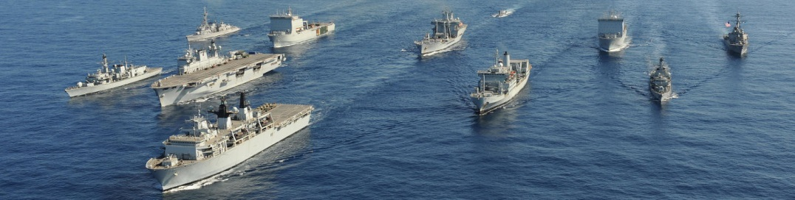

Battleships
import random

def main():
playAgain = "y"

while playAgain == "y":

sea = setupGame() # Call the subroutine to set up the game
torpCount = 10
gameWon = False

print("Welcome to Battleships!")
print("An enemy ship is hidden somewhere at sea.")
print("You have only ten torpedoes to find it.")

while not gameWon and torpCount > 0:
print()
drawGrid(sea) # Call the subroutine to draw the current state of the game
print()
print("You have", torpCount, "torpedoes left.")
print("Enter the row and column to aim your torpedo.")

tryX = int(input("Row? "))
tryY = int(input("Column? "))

if sea[tryX][tryY] == ".":
sea[tryX][tryY] = "M"
if sea[tryX][tryY] == "S":
sea[tryX][tryY] = "X"
gameWon = True
torpCount = torpCount - 1

print()
drawGrid(sea)
print()

if gameWon == True:
print("Congratulations! You sank the enemy ship!")
else:
print("Unfortunately you have run out of torpedoes and have lost the battle :-(")
print()
playAgain = input("Do you want to play again? (y/n)")

def drawGrid(sea):
print(" 0123")
for x in range(4):
print(x, end=" ")
for y in range(4):
if sea[x][y] == "S":
print(".", end="")

if sea[x][y] == "M":
print("M", end="")

if sea[x][y] == "X":
print("X", end="")

if sea[x][y] == ".":
print(".", end="")
print()

def setupGame():
sea = [["." for y in range(4)] for x in range(4)]

# Hide a ship at a random position
shipX = random.randrange(4)
shipY = random.randrange(4)
sea[shipX][shipY] = "S"

return sea

main()

